Hello and welcome to the Behavioral Business Research Lab! This guide is intended to walk you through the steps to creating a study on SONA. To get started, visit our SONA webpage‐ http:// waltoncollege.sona-systems.com/. There you will be greeted by this page:
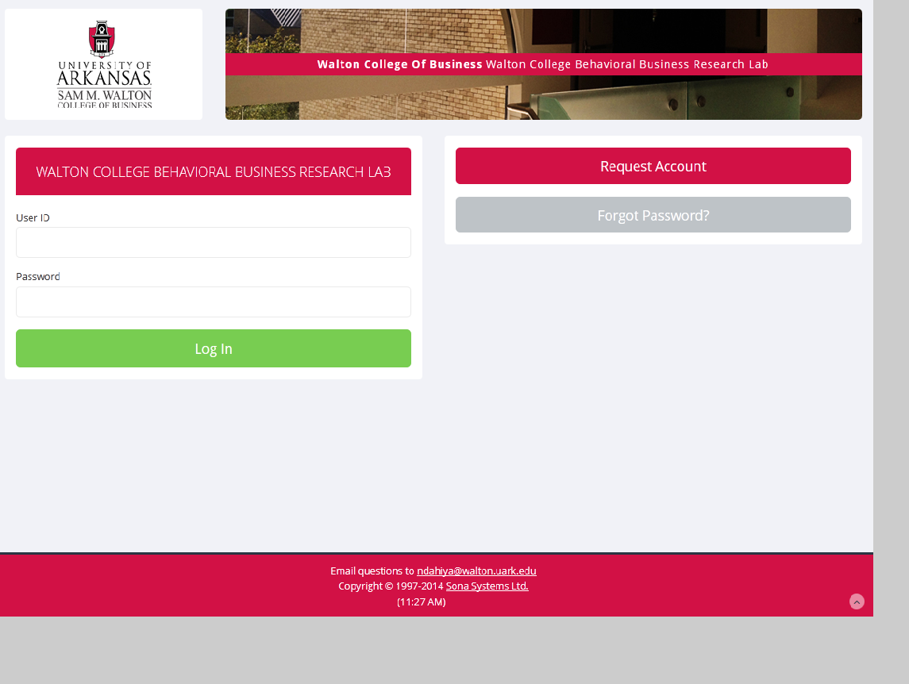

If you are a returning participant, type in your user name and password to continue on. If you are a new user looking to create a “researcher” account, please email the Lab Manager at ndahiya@walton.uark.edu. Once you are logged in, you will be greeted by the following page:
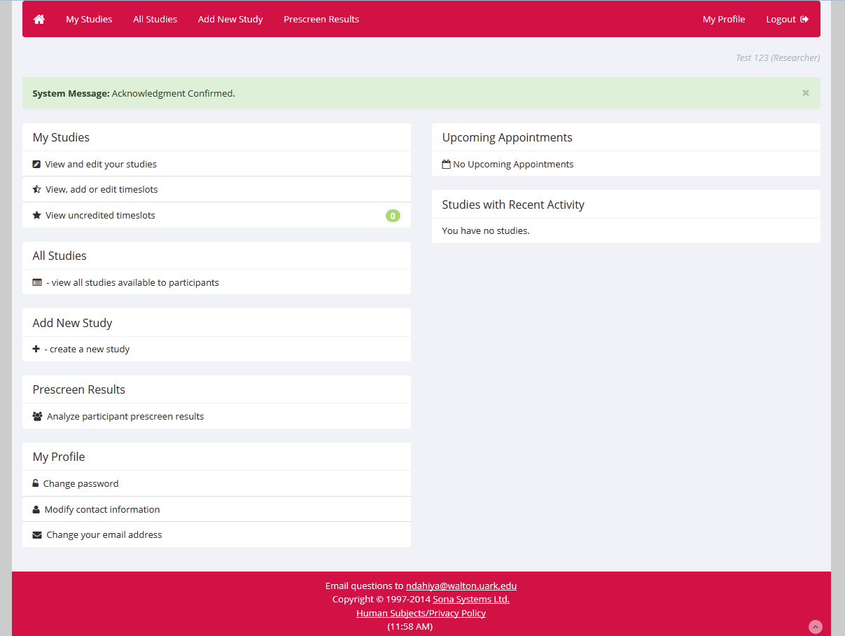
To get started on creating a new study, click on “Add a New Study” from this menu. It will then bring up options as to the type of study you wish to create. Read over the options (“Standard Study”, “Two‐part Study”, “Online Survey Study”, and “Online External Study”) and select which one best describes the activities you have in mind for your experiment. Once you have selected, click continue. You will then come to the Study Information Page, which is broken up into Basic and Advanced settings for your study.
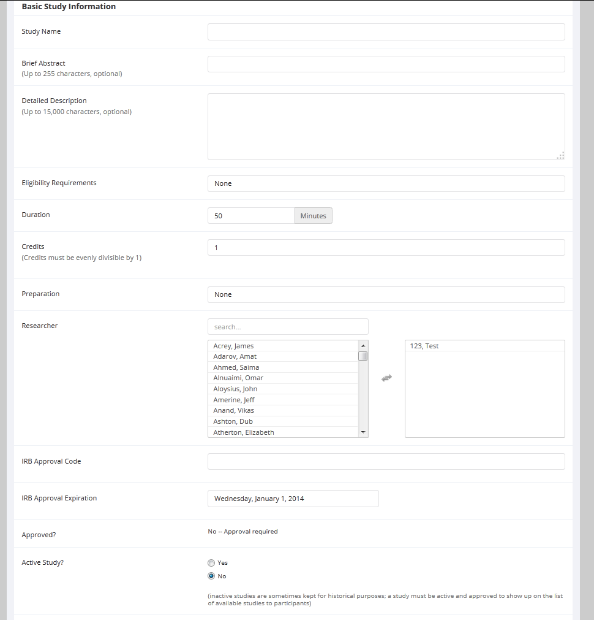
Here is where you enter in all the important information about your study, which will eventually be made visible to participants on the SONA site. The “Detailed Description” section serves to inform participants as to what they will actually be doing in your experiment‐ ex: “Watch a twenty‐minute video then fill out a short questionnaire, receive $6.00 for a half hour of your time.” The “Eligibility Requirements” section is also important if you are looking to only recruit participants with certain attributes (ex: left‐handedness). Be sure to also include the amount the study pays, or you might not get participants!
Finally, two more important pieces of information to include are the names of the researchers (yourself, faculty sponsor, and any personal RAs you may be using) and the IRB approval code. The last option listed, “Active Study?” refers to whether or not you would like the study to be visible to participants. “No” is automatically selected but in order for participants to view your study (and sign up for it) you must make your study active and get approval.
The “advanced” options are also very straightforward. You may adjust your study settings to account for prerequisites, disqualifications, multiple researchers, and deadlines‐ both the deadline participants must sign up for the study by, and the deadline they must cancel by.
Once you are finished adding information to your study, click “continue”. You will then be able to see the details of your experiment the way participants will be able to view it.
The last step is to [Send a Request] to have the study approved. Until the study is approved it will not appear in SONA for participants to view or sign up for. After you send a request to the administrator and it is approved, you may go on to make the study active, add timeslots, and recruit participants. If you are unsure how to perform these actions in SONA, please see our next walkthrough‐ “SONA Systems Guide – Adding Time Slots”.

