Hello and welcome to the Behavioral Business Research Lab! This guide is intended to walk you through the steps to creating a study on SONA. To get started, visit our SONA webpage ‐ http:// waltoncollege.sona-systems.com/. There you will be greeted by this page:
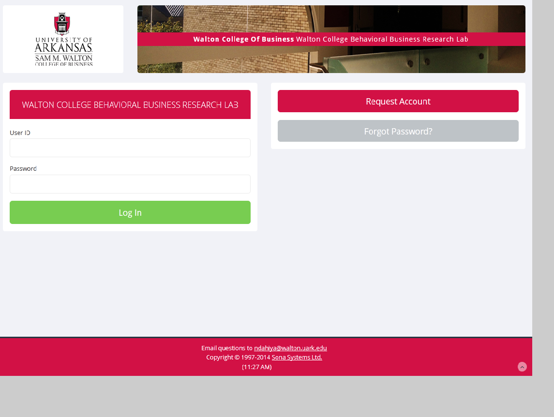

If you are a returning participant, type in your user name and password to continue on. If you are a new user looking to create a “researcher” account, please email the Lab Manager at ndahiya@walton.uark.edu. Once you are logged in, you will be greeted by the following page:
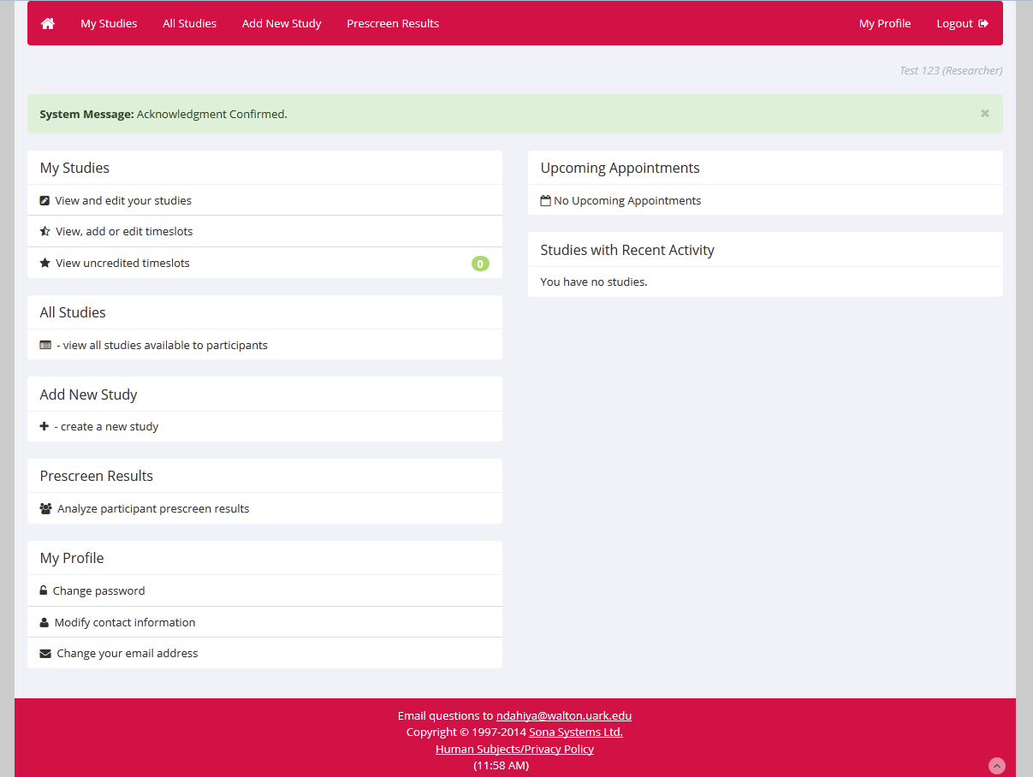
To delete time slots click on “My Studies” to view your list of approved studies. Once you bring up the list, click “Timeslots” next to the study that you wish to delete from.
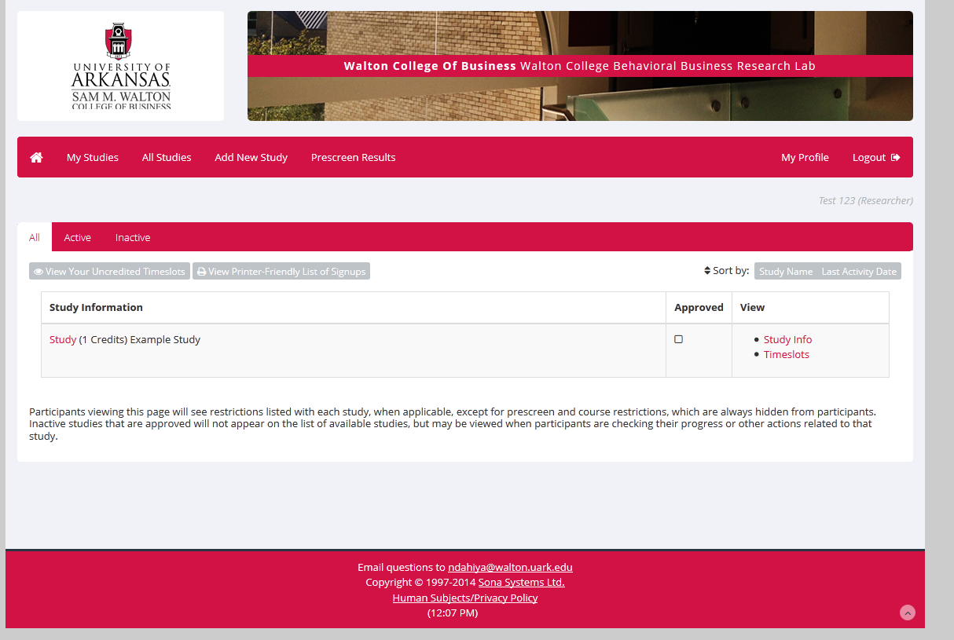
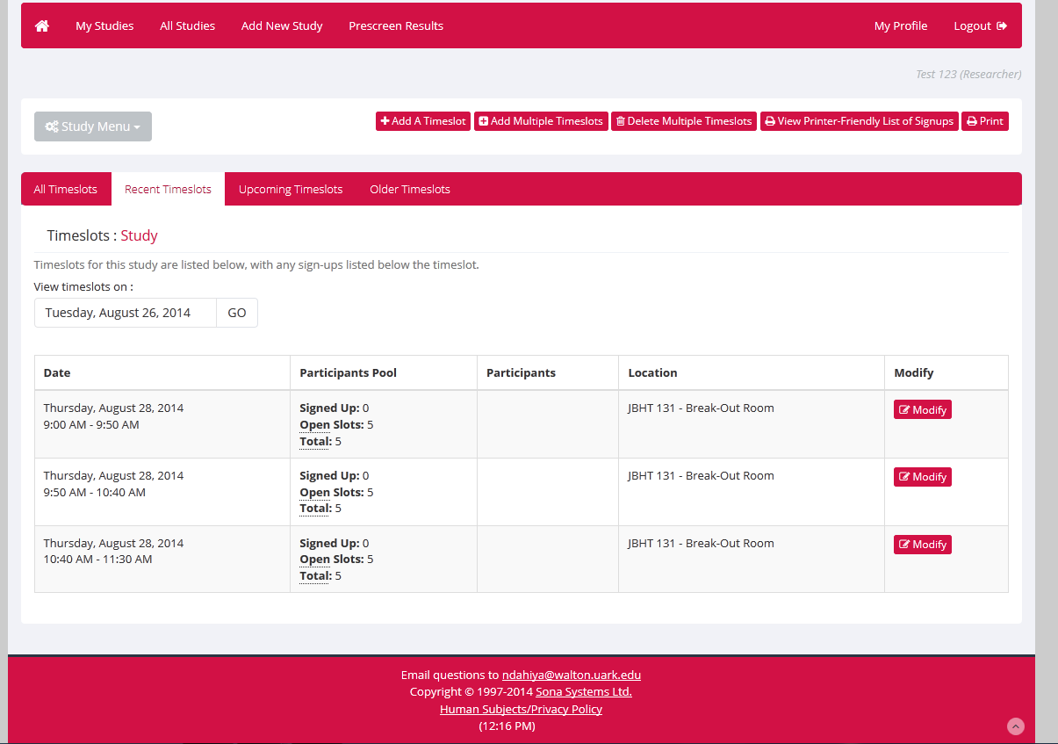

The next step is to delete time slots either one at a time, or as a group. Let’s say you’re interested in deleting one time slot due to low sign ups. Simply click “modify” next to that time slot to bring up its details:
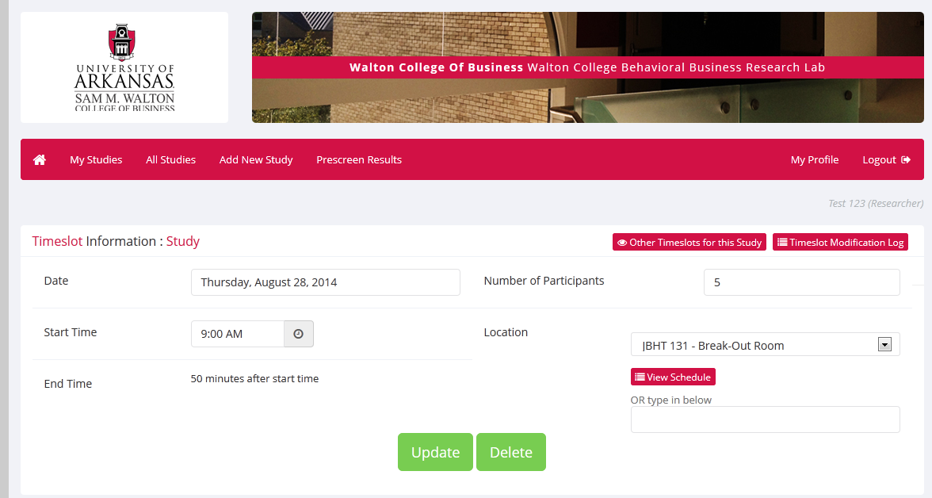
If no one has yet signed up for this slot, deleting it is simple. Just click “delete” underneath the information box. However, if a participant already signed up for the experiment you must perform an extra step before removing the slot. Next to the participant’s name will be an option to cancel them. Simply click cancel, confirm the cancellation, and then the page will display the “delete” option as shown before. SONA also automatically sends the participant a notification email of their cancellation, but if you wish to be extra careful you may choose to [Contact All Participants] and inform them that the slot has been removed.
In the event that you are interested in cancelling an entire day’s, week’s, or month’s worth of time slots, choose the “Delete multiple timeslots” option from the study’s menu. This will bring up a screen displaying all of your slots. Please note that if someone has signed up for one of your slots, that particular slot will not show up on this list. If you wish to remove a spot that someone has already signed up for, you must first cancel the participant, and then delete the slot.
Above all else, contact the lab manager if you are planning on canceling a study. This will help free up the lab room to other researchers and prevent confusion and frustration of participants if they do not receive the SONA‐generated cancellation notice.
For more information on SONA please see the other “SONA Systems” walkthroughs.

