Sona Systems, Ltd.

EXPERIMENT MANAGEMENT SYSTEM

Researcher Documentation Set
March 3, 2010

Version 2.72

Copyright © 2009 Sona Systems, Ltd., All Rights Reserved

Sona Systems, Ltd. 1
EXPERIMENT MANAGEMENT SYSTEM 1
Researcher Documentation Set 1
Version 2.72 1
Copyright © 2009 Sona Systems, Ltd., All Rights Reserved 1
RESEARCHER/P.I. DOCUMENTATION 5
Introduction 5
System Basics 5
Principal Investigator Special Note 5
Participant ID Codes Special Note 5
Getting Started 6
Logging In 6
Retrieving a Lost Password 7
Logging Out 7
Changing Your Password and Other Information 7
Email Address Options 8
Working with Studies 9
Web-Based (Online) Studies 9
Using the SURVEY CODE Feature 10
Studies for Pay 11
Two-Part Studies 12
Adding a Study 12
Updating a Study 24
Deleting a Study 24
Timeslot Usage Summary 25
Bulk Mail Summary 26
Prescreen Participation Restrictions 26
Inviting Qualified Participants to a Study 28
Viewing Your Studies 30
Participant Study View 30
Viewing Other Studies 30
Online Survey Studies 31
Introduction 31
Creating or Modifying a Survey 33
General Survey Information 33
Section List 35
Adding or Modifying a Section 36
Adding or Editing a Question 37
Copying a Section 39
Copying a Question 40
Saving Your Changes 40
Viewing a Survey as a Participant 41
Participant Withdrawal from a Survey 41
Viewing Survey Data Usage and Deleting Survey Data 42
Deleting a Single Participant’s Survey Responses 42
Analyzing Survey Responses 42
Frequently Asked Questions about Online Surveys 44
Working with Timeslots (Sessions) 46
Timeslot Usage Restrictions 46
Timeslots Linked to Specific Researchers 46
Creating Timeslots 47
Creating Multiple Timeslots 50
Modifying and Deleting Timeslots 50
Timeslot Change Tracking 51
Deleting Multiple Timeslots 51
Manual Sign-Up 52
Manual Cancellation 53
Viewing the Participant List 54
Viewing Prescreen Responses 55
Granting or Revoking Credit 56
Batch Credit Granting 57
Emailing Participants 58
Viewing Uncredited Timeslots 60
Analyzing Prescreen Responses 61
Prescreen Qualification Analysis 62
Frequently Asked Questions (FAQ) 62
Regulatory Compliance Guidelines 64
Introduction 64
Data Handling and Security Guidelines 64
Human Subjects/Privacy Policy Acknowledgment 65
INSTRUCTOR DOCUMENTATION 66
Introduction 66
Getting Started 66
Logging In 66
Course Reports 67
Granting Credits 68
Viewing Studies 69
Changing Your Password 69
Logging Out 70
Frequently Asked Questions (FAQ) 71
System Settings 72
Settings That You May Change at Any Time 73
Settings That May Only Be Changed when the System is Empty 85
Security Considerations 93
Passwords 94
Data Transmission 94
System Limits 95
Data Limits 95
Foreign Language Support 95
Accessibility Information 96
Regulatory Compliance 96
Introduction 96
Handling an Information Request 97
Data Handling and Security Guidelines 98
Strict IRB Mode 98
Human Subjects/Privacy Policy Acknowledgment 98

RESEARCHER/P.I. DOCUMENTATION

http://waltoncollege.sona-systems.com direct link to experiment recruitment system

http://waltoncollege.uark.edu/bbrl/ Walton College Behavioral Business Lab

Introduction
The Experiment Management System is used for the scheduling and management of research participants and the studies they participate in. Participants, researchers, principal investigators, and instructors all use the system for their respective purposes. As a researcher, you can set up your studies in the system, schedule the sessions (timeslots) when participants may participate, and grant or revoke credit after the session. All of this is handled through a simple web-based interface that you can access at any time, from any popular web browser.

The system is highly configurable by the administrator, to enforce the rules for the research participant pool exactly as your organization desires. It should be noted that the documentation herein may refer to features that are not enabled on your system. Contact your local administrator, whose contact information appears at the bottom of every page on the system, for more information.

System Basics
In the system, you create studies. Each study may have a number of timeslots, which are the times when you plan to run the study. Participants sign up for the timeslots by viewing a list of studies and available timeslots. You grant or revoke credit to participants after the session occurs.

Principal Investigator Special Note
This documentation applies to both researchers and principal investigators (P.I.s), when P.I. support is enabled by the administrator. A P.I. can perform all the same functions on a study as a researcher. This allows a P.I. to operate in an oversight role and monitor the progress of their studies, and step in on behalf of the researcher when necessary. Because the privileges are the same, throughout this documentation, the term “researcher” can be used interchangeably with “principal investigator” except where otherwise noted. If the P.I. feature is enabled, then all studies must have a P.I. specified.

Participant ID Codes Special Note
If enabled by the administrator, the system will identify participants to you only by a unique, system-assigned ID code, and not by their name or email address, for privacy reasons. Participants are made aware of this, and they are reminded to bring this code along with them when participating in studies, since the researcher will not know them by their name.

Getting Started
The system works best if you use any popular web browser that is less than 2 years old, like Internet Explorer, Firefox, and Safari. It will work with other web browsers, and with older versions of popular web browsers, however the layout may not be as clean. No functionality will be lost by using an older web browser.

Ask your system administrator if you need help with installing or using a web browser. This documentation assumes you have a basic knowledge of how to use the web. On this system, it is not necessary to use the Back button. You can always use the toolbar on the top to navigate to anywhere on the site.

Logging In
Your administrator should have already created your Researcher account. User name is your uark.edu name. You will need to click the option on lower left that says Lost Your Password? Click here to retrieve it! The email will come to your @uark.edu email address account. If you get a System Message that says no user was found with that email address please email Ben Armstrong at barmstr@uark.edu and request an account.
When you go to the front page of the site (the login page), you may see a link to request an account. This form is only for participants. Do not use this form to request an account, as participant accounts have an entirely different set of privileges, and the privileges are not appropriate for a researcher.

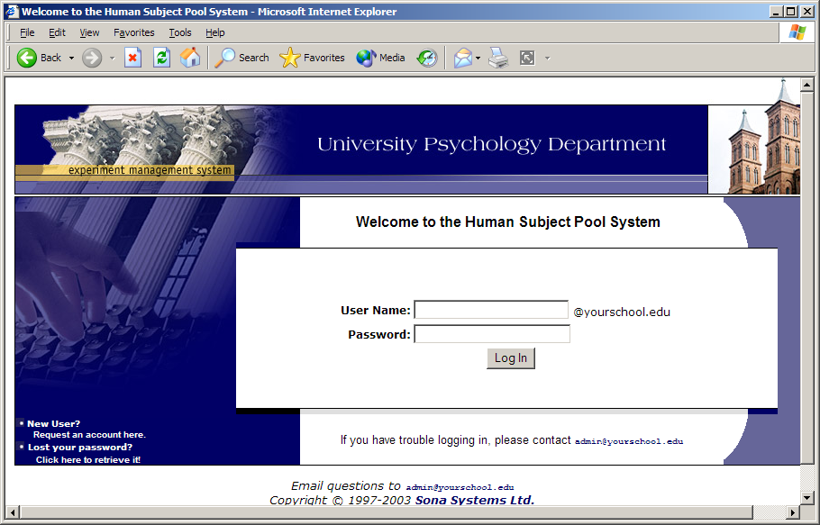
Figure 11 - Login Page
Once you login, you may be asked to review and acknowledge your organization’s human subject policy. If required by the administrator, you will need to acknowledge this once every 6 months. You will see the Main Menu after you acknowledge the policy.

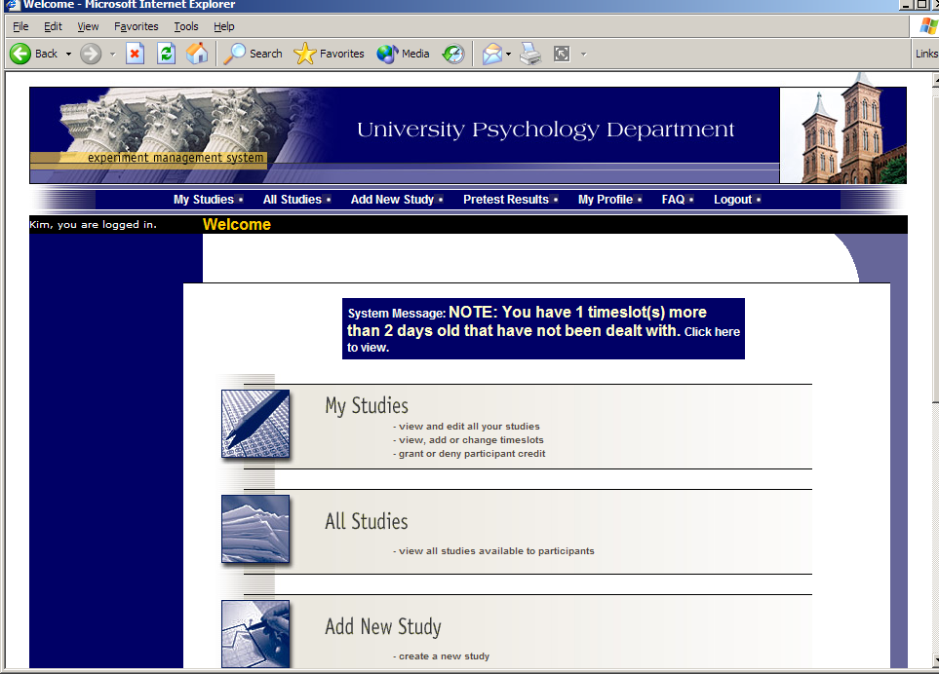
Figure 12 - Main Menu
Your login (also known as a session) will expire after a certain period of inactivity, usually 20. This is done for security purposes. If this happens, you can always log in again. When you are done using the system, it is better to explicitly log out, to prevent any problems that may arise if someone uses your computer before the session expires.

Retrieving a Lost Password
If you have forgotten or do not have your password, then you may choose to have your password emailed to you. You will see an option on the main login page. Your password will be emailed after you submit the form, and should arrive in your email box momentarily. If you provided an alternate email address (see the Email Address Options section of this documentation), it will be sent there. Otherwise, it will be sent to your main email address, which is derived from your user ID. If you requested that the system email a password to you, and it has not arrived after 30 minutes, then check in your email program’s junk mail folder in case the email was delivered there. The email comes from the account waltoncollege-admin@sona-systems.net. You may want to add to safe senders list.

Logging Out
When you are done using the system, choose Logout from the top toolbar to log out. You are now logged out. It is always a good security practice to close all your web browser windows as well, especially if you are using a computer that is shared by others.

Changing Your Password and Other Information
If you would like to change your password or other information about yourself, choose My Profile from the top toolbar. If you would like to change your password, type your new password (twice, for confirmation) in the provided boxes. If you would not like to change your password, simply leave these boxes empty.

If you change your password, please be sure to select a password you do not use on any other systems or websites. This is good computing practice, and especially important as in some cases, your password may be sent over email.

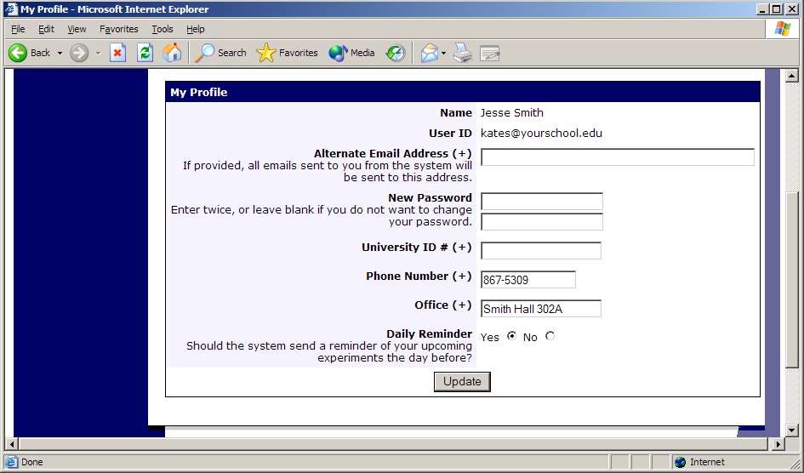
Figure 13 - Updating Your Profile
It is recommended you provide your phone number and office location, as most human subject committees require that this information be made available to research participants. If you are a researcher, this contact information will be displayed to participants when they view information about the study. If you are a principal investigator, this contact information will be displayed if a participant explicitly chooses to view it (since the researcher is the primary point of contact for a study).

Researchers may also choose to receive a daily reminder (by email) with information about all of their study sessions scheduled for the following day.

Email Address Options
There are certain events in the system which will cause an email notification to be sent to you. Most often, these are notifications that a participant has signed up or cancelled their sign-up for your studies, but there are a few other cases where it may be used as well. The email address is also displayed to the participant when they view information about the study, in case they need to contact you with questions.

You have two choices for your email address. When you update your personal information, you will see a box where you may provide an alternate email address. If you provide such an address (this could be a Hotmail account, for instance), this is the address where any notifications will be sent, and this is also the address that will be displayed to other users (including participants in your studies).

If you do not supply an alternate email address, the system will derive your email address from your username. Typically, it will add your organization’s Internet domain to the end of your user ID to form the address, so if your user ID is “jsmith” and your organization’s Internet domain is “yourschool.edu” then it would derive your email address as “jsmith@yourschool.edu”.

In situations where the system is configured so you may enter an email address on this page, you will be asked to enter it twice when changing the address, to ensure it is typed correctly.

In some cases, depending on how the system is configured, you will be required to provide an email address (which will be listed as “Email Address” instead of “Alternate Email Address”) and all emails to you will go to that address.

Working with Studies
Most of your time on the system will be spent, not surprisingly, using the study-related features of the system. Be sure to read this section closely, in its entirety, as there are special features and situations you should be aware of.

Web-Based (Online) Studies
If enabled, you may set up studies that are web-based (online), and these studies may be set up internally in the system (as a survey) or outside the system. The options will vary depending on how your system is configured.

There are a few things to note about web-based studies:

- Once you indicate to the system that the study is web-based, you will not be able to change it so that it is no longer web-based (but you can deactivate or delete the study). So, make this choice carefully
- Web-based studies are typically setup so there is one timeslot, and that timeslot contains the maximum number of participants you would like to participate, and the last date and time when they can participate (often, this is the end of the term). It is not recommended that you set up multiple timeslots for a web-based studies (it confuses participants), though the system will support it. It is acceptable to have multiple timeslots where more than one is not active at a time. For example, one could have had a deadline date of the end of the previous semester (and thus is currently in the past), while the current timeslot has a deadline date of the end of the current semester (i.e., in the future).
- It is generally assumed that participants will participate in an online study shortly after they sign up. Because of this, the system will expect you to grant credit to them soon after they sign up. If you are creating an online survey within the system, credit will be granted automatically, immediately after the participant completes the survey.

Throughout the sign-up process, participants are notified that the study is web-based.

If the study is not administered by the system, then participants are not given the URL for the website until they have signed up, to ensure they do complete a sign-up in the system for the study. They can see the URL after sign-up, and up until the timeslot they signed up for is still in the future. Once the timeslot they have signed up for is in the past, they no longer have access to the study URL. This is done to prevent participants from accidentally clicking on the URL in a subsequent semester and participating in the study twice. This restriction regarding viewing the study URL applies only to participants, and only to web-based studies administered outside the system.

Online survey studies (surveys administered by the system) are discussed in great detail in the section Online Survey Studies, later in this document. Please read it carefully before setting up an online survey study.

For web-based studies administered outside the system, you will want to develop some method of linking the participant’s sign-up in the system to your online study, so you know who to grant credit to. One way to do this is to ask the participant’s name (or some other identifying information) that will make it easy to locate their sign-up within the system and grant them credit once they have completed your online study. Another method of tracking, which offers more anonymity, is to use the Survey Code feature described below. Note that in all cases, for web-based studies administered outside the system, the system will not automatically grant credit once the participant has finished the study, and the reason is that the system does not know when something occurred on a website outside the system. For this reason, researchers should routinely login and grant credit as necessary.

Using the SURVEY CODE Feature
For web-based studies which are administered outside the system, there is a special facility available for advanced users to track sign-ups in their web-based study while still preserving confidentiality. This feature applies only to web-based studies administered outside the system.

Before going further, it is important to note that this is an advanced feature and may require some programming skills. Sona Systems will not provide technical support for any programming questions.

The way this feature works is that if the text %SURVEY_CODE% is placed anywhere within the Study URL field, the system will automatically replace this text with a unique number for the participant. This unique number will also be displayed next to their sign-up within the system, so it’s easy to match sign-ups by this number. The number can be anywhere from 4-7 characters in length.

The external study will then need to be set up to process this code and log it appropriately. Sona Systems will not provide technical support or code samples on how to program an external study, as that is code that is external to our software.

Here is an example of how this works. Let’s say the study URL is:
http://www.myschool.edu/mysurvey.html

If the Study URL is entered in the system as:
http://www.myschool.edu/mysurvey.html?id=%SURVEY_CODE%
then when a participant clicks on that URL, the system will replace %SURVEY_CODE% with a unique numeric value to identify the participant. For example, the URL may be changed to:
http://www.myschool.edu/mysurvey.html?id=30039

If that is the case, then on the page in the system listing sign-ups for this study (i.e., in the timeslot), the code 30039 will appear next to that participant’s sign-up.

If this code is parsed and handled by the external study, then the researcher can easily link up the sign-ups in the system with who they have collected data from within their external study, so they know who to credit. Note that the crediting still will not occur automatically. The purpose of this feature is to provide a way to identify participants without compromising privacy, since the system can then be configured so that names are not displayed next to sign-ups.

To help with setting this up, if a participant is not viewing the URL (for example, the researcher is viewing the URL), this special survey code text will simply be removed. Note this special text must be in all capital letters, and surrounded by percent signs. You may confirm it was entered correctly because a sample URL will be displayed when you go to view (not edit) the study, below the normal study website link.

If you provide a Survey Monkey URL, the system will provide guidance (after saving your changes) about how to use the survey code feature. In short, by adding the text &c=%SURVEY_CODE% to the end of the Survey Monkey URL, that should allow Survey Monkey to keep track of the unique survey code for each participant. You may read more about this on Survey Monkey’s site, by searching for help on “web link collector.”

Studies for Pay
You may have a situation where participants are compensated for their participation in the study. They may or may not also receive credit for the study. If the study is not for credit, you may set it up as a pay-only study and specify the compensation amount. If participants are compensated and they receive credit, you should set it up as a credit study and indicate additional compensation in the study’s information section.

Regardless of the type of study, after a participant participates in a study (including studies that are for pay only), you should still go into the system and indicate their participation by noting their participation or no-show when viewing their sign-up This allows the system to properly enforce certain restrictions on the participant and their studies, like pre-requisite and disqualifier study restrictions.

Two-Part Studies
You may create a two-part study in the system. Often, these are studies involving memory research, where the participant must return a specified number of days after the first session. When creating a study, you may specify the day range for the second part of the study (e.g. 7 to 10 days after the first part). Participants are required to sign up for both sessions at the same time, to reduce the chance they will forget to sign up for the second part. Each part of a two-part study may have a different credit value and duration, but each part must be the same type – either both parts are for credit or both parts are for compensation. Online studies may not be two-part studies.

You may specify that the second part of the study must be scheduled to take place at the exact same time as the first part (on a different date), or at any time on the dates that are the specified number of days after the first part.

You should ensure there are enough available timeslots for both parts of the study, or participants will be prevented from signing up for either part. Participants may cancel either part of their sign-up if necessary. If they cancel the first part, the second part is automatically cancelled as well. If they cancel only the second part and the first part has already occurred, and they would like to participate in the second part later, you will need to manually sign them up for the second part (if you are allowed to do so), or ask the administrator to handle this.

If you grant a no-show for the first part of a two-part study, the second part of that participant’s sign-up will not be cancelled automatically, but you will be reminded of the situation in case you would like to cancel the second part. The cancellation is not automatic as there are some situations where automatic cancellation is not desirable.

Adding a Study
Some researchers choose to set up their studies in the system before they have received the proper approvals (usually from their IRB) to run the study. This is supported in the system. You can setup a study but specify that is it not visible to participants (this is the approved setting). That way, as soon as your approval is received, you can simply make the study visible and everything else is already prepared. You can also post a study and make it visible immediately, if that is appropriate. Some systems will be configured in such a manner that only the administrator can approve the study, in which case you will need to contact the administrator to do so.

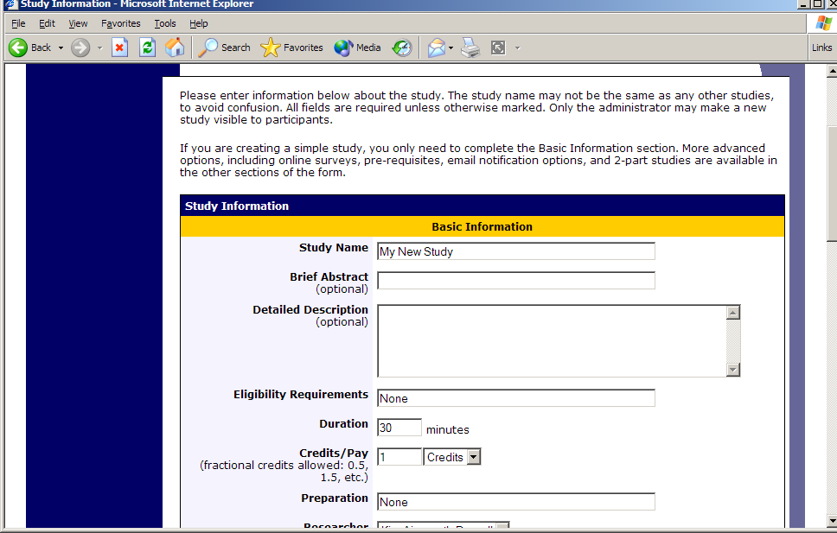
Figure 14 - Adding a New Study
To add a study, choose the Add New Study option from the top toolbar. You will need to pick from four possible types of studies. Please choose this carefully as you are not able to change this later.

After you choose, the study type you’ll see a form asking for more information. You will need to fill out a number of fields, which are explained in the following table. Some of the fields listed below may not appear, depending on how your system is configured and the type of study you selected. All fields must be filled out unless otherwise noted.

Field | Explanation
Study Name | A short name for the study. This is how the study is identified throughout the system. Most systems are configured so studies show in a random order to participants (choose Your Studies on the toolbar and it will state at the bottom of the resulting page if they are displayed in random order), so there is no advantage in choosing a study name that might put it at the top of an alphabetical list. You should consult with your administrator if there is a naming convention to be followed when naming studies. Study names must be unique, and you will be prevented from adding a study if there is already another study in the system with the same name. A study name may be up to 100 characters in length.
Brief Abstract (this feature might be disabled on your system) | This is a short one or two line description of the study. This short description will be displayed to participants when they view the entire list of studies, so you may want to list the most pertinent details here. Studies configured for payment usually have the compensation information included here, particular if the payment varies based certain outcomes. This field may be optional, and can be up to 255 characters in length.
Detailed Description (this feature might be disabled on your system) | This can be a rather lengthy description about the study, and it will show if a participants clicks on the study to get more information, before they sign up. You may include basic HTML in this area, but please be sure you know what you are doing (ask your IT department for help if you are unsure). If you would like to add a carriage-return (paragraph break), simply type in “<p>” (without the quotes).This field may be optional. The maximum length of this field is 15,000 characters.
Eligibility Requirements | If there are any restrictions on who may participate (for instance, only those who are left-handed), list them here. Otherwise, leave the field as-is. If you list any restrictions, these will be displayed on the list of studies, when participants view a list of all available studies. Note the system does not enforce these restrictions, but it is expected a participant will only sign up for a study in which they are qualified, since they would otherwise fail to receive credit. In most cases, you will leave this field as-is and set prescreen participation restrictions, which you can do after you add the study. This field may be up to 245 characters in length.
Pre-Requisites (this feature might be disabled on your system) | If there are studies a participant must participate in before participating in your study, choose them here. You may select multiple studies, and on most systems, you hold down the Ctrl key and click the desired studies.  You may specify that participants must have participated in all of the studies you specify, or at least one of the studies specified.  The system will handle enforcement of the pre-requisites in a strict or lenient fashion depending on how your system is configured. In strict enforcement mode, the participant must have received credit for (participated in) the pre-requisite studies. In lenient enforcement mode, the participant must only be scheduled to participate in the pre-requisite studies (it is assumed they will go on to complete the pre-requisite studies). You can ask your administrator how this is configured, if it is of concern. If your system is in lenient enforcement mode, and a participant cancels a necessary pre-requisite for you study (they are warned of this situation), and you have configured your study so that the researcher will receive notifications of cancellations or sign-ups, then the researcher will receive notification of the pre-requisite problem and can contact the participant if necessary.  If there is a long list of studies for this setting, an Enlarge List button will appear. You can click this to make the list of studies larger and thus easier to click on.  Depending on how your system is configured (Pre-Requisite/Disqualifier Display setting), participants may or may not see which studies you have specified as pre-requisites when they go to view your study.
Disqualifiers (this feature might be disabled on your system) | If there are any studies a participant must not have participated in, please select them here. You may select multiple studies. The system will handle enforcements of the restriction, during the sign-up process.  If a study has some other study listed as a disqualifier, and a participant signs up for this study, then they will be prevented from signing up for the disqualifier study.  If there is a long list of studies for this setting, an Enlarge List button will appear. You can click this to make the list of studies larger and thus easier to click on.  Depending on how your system is configured (Pre-Requisite/Disqualifier Display setting), participants may or may not see which studies you have specified as disqualifiers when they go to view your study.
Course Restrictions | If you would only like participants enrolled in certain courses to participate in your study, select the eligible courses here. Participants who are not in at least one of the courses you selected will not see the study when they go to view the list of available studies. You may choose No Restrictions if you would like to make the study available to participants in all courses.  If there is a long list of courses for this setting, an Enlarge List button will appear. You can click this to make the list of courses larger and thus easier to click on. There is a limit to how many courses can be listed as course restrictions for a study, and the limit is somewhere between 60 and 80 courses. The limit is variable depending on a few factors, and the system will simply not save the course restrictions for any courses which would take it over the limit.
Duration | The amount of time, in minutes, that each study session will take. If you are setting up a 2-part study, then this setting applies to the first part of the study. For online studies, this should be an estimate of how long participants can expect the study to take, so that they can plan accordingly.
Timeslot Usage Limit | Depending on how your system is configured, you may see an item that specifies the maximum number of study session hours available to this study. This value is set by the administrator, and only the administrator can adjust it. To determine the current session usage for a study, go to the Add A Timeslot page for the study, and the usage will be listed there.
Preparation | Enter any advanced preparation a participant must do here (e.g. “do not eat 2 hours before session”). If there are no preparation requirements, leave this field as-is.
Invitation Code (this feature might be disabled on your system) | If you would like to have a special sign-up password for this study, enter it here. This is known as an invitation code, and applies just for this study. Participants must know the invitation code to sign up for this study. This is often used in cases where the researcher wants to personally select participants, so the researcher only provides the invitation code to the desired participants.  If you do not need an invitation code, leave this field blank.
Is this a web-based study? (this feature might be disabled on your system) | If this is a web-based (online) study, choose the type of online study it is. If you have set up the study on another website, you should note the study is administered outside the system. If you want to set up an online survey study to be administered by the system, select the appropriate option.
Should survey participants be identified only by a random, unique ID code? | This only applies to web-based studies administered by the system, and only if participant anonymous ID codes are not already turned on system-wide. If set to Yes, participants are only identified by a unique system-assigned ID code, to protect their privacy. Participants are also notified of this when they start the survey. Once enabled, this setting cannot be changed after participants have taken the survey, as a matter of privacy protection.
Study URL | The URL (web address, usually starting with http://) for your study. This is only required for web-based studies administered outside the system.  If you are setting up a web-based study outside the system, and would like the system to pass a unique identifier in the URL so you may easily identify participants, add the text %SURVEY_CODE% in the URL where you would like the identifier to be placed. This is discussed in further detail in the Web-Based (Online) Studies section of this documentation.
Credits/Pay | Enter the number of credits or compensation for the study. A value of 0 is acceptable, and may be desired in cases where the study is part of a set of studies, where only the final study is credit-earning. Please see the Studies for Pay section of this documentation for more information on how to fill out this field in the case of for-pay studies. If the study has a credit value, the credit value specified must be evenly divisible by the credit increment specified. For example, if the increment is 0.5, then the study can have credit values like 1 and 1.5, but not 0.75.  If you are setting up a 2-part study, this is the value for the first part of the study.  After a study has sign-ups, you may not change the credit value of the study. However, the administrator can change the credit value, in certain situations.  A study may not be changed between a study for credit and for payment, after it has been created.
Is this a 2-part study? | Select Yes or No if this is a 2-part study. You can only decide this when creating a study (not when editing it), and this setting may not be changed after the study is created. See “Two-Part Studies” for more information.
Credits/Pay, Part 2 | Enter the number of credits or compensation for part 2 of the study, if this is a two-part study (the value is ignored otherwise). A value of 0 is acceptable, and may be desired in cases where the study is part of a set of studies, where only the final study is credit-earning. Please see the Studies for Pay section of this documentation for more information on how to fill out this field in the case of for-pay studies. If the study has a credit value, the credit value specified must be evenly divisible by the credit increment specified. For example, if the increment is 0.5, then the study can have credit values like 1 and 1.5, but not 0.75.
Part 2 Duration | The amount of time, in minutes, that part 2 of the study will take.
Part 2 Scheduling Range | Specify the number of days (as a range) after part 1 is scheduled, that part 2 should be scheduled. This setting only applies to two-part studies. The range may be the same value (e.g. “between 7 and 7 days”) if desired, but must be a whole number. See “Two-Part Studies” for more information.
Part 2 Scheduling Leniency | In some cases, you may want to ensure that the participant schedules the second part of the study to take place at exactly the same time (on a different date) as the first part. If so, choose Yes for this option. If there is some flexibility so they can sign up for any time within the Part 2 Scheduling range, choose No for this option.
Researcher(s) | Select the researcher for this study. Most likely, this is you, and your name will automatically be selected. If you are a researcher, then you may not change who the researcher is (the P.I. for the study, as well as the administrator, can change the researcher). Depending on how your system is configured, you may be able to specify multiple researchers for a study. If you specify multiple researchers, each researcher has full control over the study.  The pulldown box lists only users who are researchers.
Principal Investigator (this feature might be disabled on your system) | Select the Principal Investigator for this study. The person you select will have full access to the study. If you see this option, then you must select a P.I.  The pulldown box lists only users who are principal investigators.
IRB Approval Code | Enter the IRB approval code here. This field is displayed to the administrator to help them keep track of studies. This field may be required depending on how your system is configured.
IRB Approval Expiration Date | The date when IRB approval expires. This field may not appear if your system is not configured for it. If it does appear, you must provide a valid expiration date. The system will prevent you from adding new timeslots to take place after this date, and your study will become inactive (not approved and thus not visible to participants) after this date. You may not make a study active if the IRB approval has expired. Only the administrator can change the IRB approval expiration date, once it has been entered, which is why it defaults to blank to force you to choose a date. You may specify a date up to 5 years in the future.
Approved? | Select Yes if this study should show up on the list of studies which participants may sign up for. Ensure you have received the necessary approvals to run the study before choosing Yes. A study must be Approved and Active to show up on the list of studies which participants may sign up for.  If you select No, the study will not be visible to participants.  Some systems are configured such that only the administrator can approve a study. If that is the case, you should contact the administrator when you are ready to make the study visible to participants – and a handy form is provided on the page to do so. As a researcher, you can always make a approved study invisible to participants (by making it not approved), but you may need the administrator to make it visible again, if so desired. In addition, if you change key items about the study, specifically the name or descriptions, the study will automatically be made invisible to participants, until the administrator reapproves it (if the system is configured this way). The reason for this is that many IRBs approve very specific language for study names and descriptions, so the administrator needs to ensure the study is in proper compliance.
Email Approval Notice? (visible to administrators only) | This Yes/No option will appear if the administrator is adding or updating the study, and it is not already approved. If they select Yes to Email Approval Notice and they approve the study (set Approved to Yes) at the same time, then an email will be sent to all researchers for the study, to notify them that their study was just approved.
Active Study? | Select Yes if this study is in progress. You must select Yes and the study must be Approved if you want the study to show up to participants so they can sign up for it.  If a study is Not Approved but is Active, then it does not show up (to participants) on the listing of studies, but it is accessible through other links if the participant has participated in it before and they are viewing their participation history (in case the participant has follow-up questions about the study). It will also show up on the study information page (for an individual study) when it is listed as a pre-requisite or disqualifier for a study.  The reason to select No is if the study is being kept for historical purposes, but should not show up to participants on the list of studies they may sign up for. Often, this is done so the system can enforce pre-requisites, where the inactive study is a pre-requisite for an active study.
Should the Researcher receive an email notification when a participant signs up or cancels? | If set to Yes, the researcher for this study will receive an email notification whenever a participant signs up, or cancels their sign-up, for this study. The email notification will be sent to an email address based on the information the researcher has provided. See the Email Address Options section of this documentation for more information on how the email address is determined. Emails will contain the first 50 characters of the study name as part of the subject line, to make it easy to sort the emails with an email program that supports filtering based on subject line.  If set to Yes, researchers will also receive a notification if the system is in lenient pre-requisite enforcement mode and a participant cancels a study that was a pre-requisite for the current study. Read the section on Pre-Requisites in this table for more information about this situation.  Emails are sent to all researchers specified for the study, unless a specific researcher is assigned to the timeslot that the email notification is being sent about. See Timeslots Linked to Specific Researchers for more information.
Researchers at Timeslot-Level | If set to Yes, it will be possible (but not required) to assign a specific researcher (from the list of researchers for the study) to a timeslot. If set to No, then it is assumed that all researchers (assigned to the study) are responsible for all timeslots. See Timeslots Linked to a Specific Researcher for more information. This option only appears if the system is configured to allow multiple researchers per study.
Automatic Credit Granting | If set to Yes, timeslots that are more than a specified number of hours old and still in the Awaiting Action state will be changed to a credit grant. The check for timeslots in this situation is made only once per day. If an automatic credit grant is done, you may still change it later if necessary.  For online external web studies, the credit grant will take place the specified number of hours after the timeslot (participation deadline) has occurred, so this feature is generally not useful in this situation. This option will not appear for online survey studies (within the system) because credit granting generally occurs automatically, immediately after the participant completes the survey.
Can a participant sign up for this study more than once? (this feature might be disabled on your system) | If you would like to allow participant to sign up (and receive credit) for your study more than once (at different times), choose Yes. Otherwise, choose No.  If No is chosen, participants may only sign up for the study more than once if they previously failed to show up for the study (a no-show).
Private Comments | This is an optional area where you may enter any comments or notes about the study, which are only visible to the researchers for this study, and not to participants. The maximum length of this field is 3,000 characters.
Participant Sign-Up Deadline (this feature might be disabled on your system) | Enter the deadline before the study is to occur that the participant may sign up, in whole hours.
Participant Cancellation Deadline (this feature might be disabled on your system) | Enter the deadline before the study is to occur that the participant may cancel their existing sign up, in whole hours. Generally the cancellation deadline should be shorter than the sign-up deadline, so participants can easily cancel an accidental sign-up.

Once you have filled out the appropriate information, save it and the system will be updated immediately with the information. Your next step is likely to add timeslots (sessions). See the Working with Timeslots section of this documentation for more information.

If you need to update this study, see the following Updating a Study section of this documentation. If you would like to add participation restrictions based on prescreen responses, you can do so when you update the study (see Prescreen Participation Restrictions).

Updating a Study
You may update any of your studies at any time. To do so, choose My Studies from the top toolbar, and you will see a list of your studies. Click on the desired study, and choose the Change Study Information link.

You will see a form remarkably similar to the one you used to add the study. A few options may no longer be changeable depending on the status of the study (e.g., if participants have already signed up for it). The fields shown are all the same as when you added the study. See the Adding a Study section of this documentation for an explanation of those fields.

The changes you make will be will be take effect immediately after they are saved. When changes are made, if administrator re-approval is required before a study is made visible to participants, then you should contact the administrator to request re-approval once you have made all your changes. Changing the following fields may require a re-approval: study name, brief abstract, detailed description, eligibility requirements (the text field, not specific restrictions like prescreen restrictions, study pre-requisites/disqualifiers, or course restrictions), duration, preparation, credit value (for credit studies only). There will be a notice on the Change Study Information to warn if re-approval may be required, and they system will also notify you, after making changes, if the study is now in need of re-approvl.

If you need to change the credit value for a study, and there is no option to do so, this means the study already has at least one participant signed up for it. You cannot change the credit value when a study is in this situation because there is no easy way to handle past credits for the same study (e.g. should old credit grants for the same study be adjusted to reflect the new credit value, or kept the same?). If the study is nearing the end of its run, and variable credit granting is enabled, then the easiest solution is to grant the new credit value to participants who sign up in the future. If you prefer that the credit value is changed for the entire study, contact the administrator, who can make the change for you under certain conditions (which depend on the credit status of existing sign-ups for the study).

Deleting a Study
You may delete a study only if participants have not signed up for it. If you need to delete a study which already has sign-ups, you should make it Inactive instead, if you do not want it to be visible to participants. You may not delete a study which has sign-ups, so the option will not be presented.

If you want to delete a study that has sign-ups, please contact the administrator. The administrator can delete a study with sign-ups, but only if the sign-ups are all without credit values (this usually occurs when study participation history from a previous semester was retained, but credits were zeroed out). If the study has sign-ups where the sign-ups have (non-zero) credit values linked to them, then the administrator cannot delete the study until all those credit grants are changed to a 0 value (or the participants for the sign-ups are deleted). The reason for this restriction is to ensure that the credit count for participants where they have earned credits is accurate, which means that the studies which contributed to their credit earnings must be kept intact.

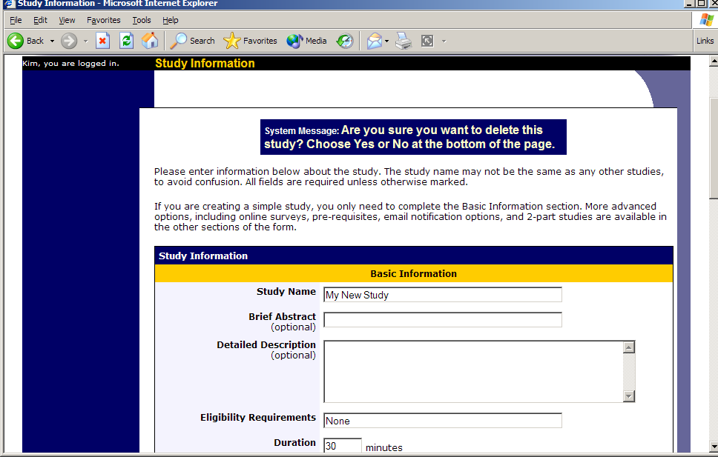
Figure 15- Deleting a Study
To delete a study, choose My Studies from top toolbar, click on the desired study, then choose the Delete Study option. You will see a confirmation page. Choose Yes (at the bottom of the page) to delete the study.

Once a study is deleted, it cannot be restored, so use this feature very carefully. If you delete an online survey study, the survey and all data collected will also be deleted.

Timeslot Usage Summary
The timeslot usage summary is available when viewing your study. This gives some basic information about timeslot utilization in the past and in the future, as well as some basic no-show information. It also gives information on timeslots for the study by location (if the study is not an online survey study or external web study), and by researcher (if the study is configured to allow researchers to be assigned to specific timeslots).

For credit studies, the system also provides a summary of how many credits were granted. This summary accurately computes credit usage, taking into account any variable credit grants (if Variable Credit Granting is enabled in System Settings), where some participants may have received credit in a different amount than the study’s listed credit value.

If timeslot usage limits are enabled, the system will provide an estimate of how many timeslots can be added. Note that if the study is a two-part study, it will estimate based on allocating all the limit to the first part or the second part (both estimates are provided), however in practice it’s more likely a researcher will want to add timeslots to both parts of the study, so this should be taken into account when viewing these estimates, especially if the first part and second part of a study have a different duration.

Bulk Mail Summary
The system tracks whenever any type of bulk email is sent (by a user) related to the study. This includes inviting participants based on the study’s prescreen participation restriction analysis, or contacting those who have already signed up for the study. This information is kept for 6 months, and it is tracked to ensure that all users follow generally accepted Internet practices for responsible use of email. The administrator also has access to this information.

Prescreen Participation Restrictions
If enabled on your system, the system might contain an online prescreen that participants may (or must, depending on your system configuration) complete. You may place participation restrictions on your study based on prescreen responses. Participants are unaware that such restrictions are placed on the study. These restrictions are never listed to them. If they do not qualify to participate in a study because they do not meet the prescreen participation restrictions, then the study will simply not be listed to them. This is important to note – participants never know why a study was or was not listed to them, because they are unaware of the prescreen restrictions.

You may restrict a study on any question or questions on the prescreen that allowed for a multiple-choice answer where only one choice could be selected. You may also restrict a study based on a computed section sum or average score for a participant, if the prescreen was set up in such a manner. You may restrict to one choice or many choices for any question. If you restrict on multiple questions, it is the same as a logical “AND.” For example, if you setup the prescreen restrictions so that participants must have answered “Yes” to a “Do you wear glasses?” question and “Blue” or “Grey” to “What color are your eyes?”, then they must meet both requirements to participate. In other words, only participants who wear glasses and have either blue or grey eyes are eligible. There is no support for a logical “OR” restriction across multiple questions. The restrictions are inclusive, which means that if you select a choice as a restriction, then participants must have answered at least one of the choices selected for each question that is part of the restriction in order to see and participate in the study, as opposed to exclusive where checking the choice as a restriction would exclude them from participation.

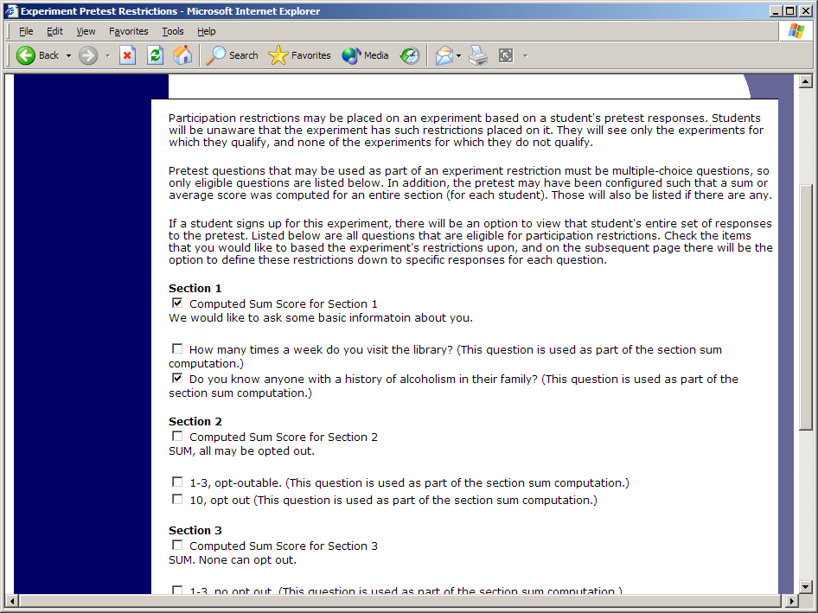
Figure 16 - Prescreen Restrictions Question Selection

To set participation restrictions, view (do not choose edit) your study and choose View/Modify Restrictions. You will see a list of eligible questions which you may use for your restrictions. If the study already has some restrictions, those will be checked, and you will see how many participants currently meet the restrictions. Choose the questions you would like to restrict upon (and keep the existing checked restrictions checked, unless you want to remove that restriction), and click on the Set Restrictions button. On the subsequent page, you can select each value that is acceptable for each question you have chosen. Once you have selected all the acceptable values, save your changes and they will take effect immediately. It is important to note that if you change the restrictions, it will not remove the study sign-ups for participants who qualified under the previous set of restrictions. For this reason, you should probably decide on your restrictions before making the study available to participants.

If you have restriction requirements where you would like to restrict participation to a percentage of the population (for instance, the responses that were chosen by the top 25% of people), but you are not sure which responses meet this requirement, you can use the prescreen response analysis feature to determine the valid responses. See Prescreen Response Analysis for more information. You may also use Analyzing Prescreen Responses to get an idea of how many participants are potential candidates for participation in your study, based on a specified set of restrictions.

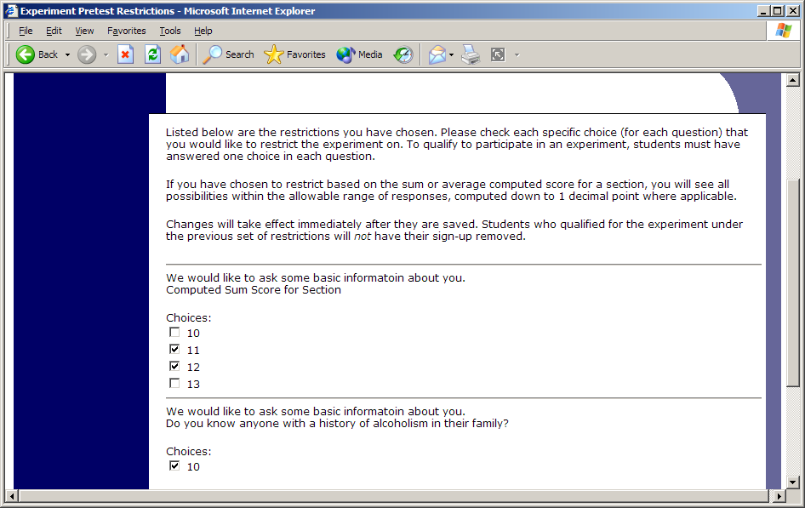
Figure 17 - Prescreen Response Restrictions

Inviting Qualified Participants to a Study
While viewing the list of prescreen restrictions currently set for a study, and the number of participants who meet those restrictions, you may see the option to Invite Qualified Participants. Using this option, you may craft an email to be sent to all qualified participants. You may choose to exclude those who have already signed up for or participated in any studies you specify. The system will pre-fill the email text with useful information like the name of the study and how many timeslots are currently open. You cannot include attachments in the email, so if you have a document you would like to include, you should post it on a university webserver and provide a link to the document in the email you send.

If you have set participation restrictions for the study based on course enrollment, those restrictions will be taken into consideration (i.e. abided by) when determining which participants receive the email.

There is also an option to choose a random percentage from the overall list of matching participants to email. It is important to understand that the system does not keep track of which random percentage of the group of matching participants is sent to each time, so that if you send to a random 30% now, and a random 30% an hour later, it could very well be the case that many participants receive the email on both those occasions.

The From (sender) address on the email will be the administrator email address, which is done to prevent the email from being blocked by junk email filters. The “Reply To” address of the email will be that of the user who is actually sending the email, so when a user chooses to reply to the email, the reply will be sent to that (the reply to) address.

Finally, there is an option to specify a delay in sending the email, based on the number of hours from when the emailing option is used. This is useful if you want to target a certain time of day (e.g., during the evenings) when the email will be sent. The emails are generated at the time you use the emailing facility, but are stored on the server until the specified sending time. They cannot be removed from the queue once this emailing facility is used.

In some cases, the administrator may have imposed a limit on how many participants may be emailed. This is often done to prevent abuse of the system, such as cases where researchers invite too large a number of participants and this is not in accordance with generally accepted Internet principles for sending email. If there is such a limit, the system will look at the number of participants the researcher plans to email, and if that number is greater than the limit, it will block the sending entirely, as opposed to sending only enough emails up to the limit. To get around this limitation, the researcher can further restrict who they plan to send to (perhaps choosing a smaller random percentage of users, or more closely defined prescreen participation restrictions), or ask the administrator to send the email for them. The administrator is not subject to such limitations. Regardless, any use of this bulk email facility will be logged, and that information will be kept for approximately 6 months. The administrator can easily pull up a report of how many emails a specific researcher has sent, so is good to be careful about not abusing this feature. In addition, Sona Systems reserves the right to temporarily remove the right to login from a researcher if there are verifiable reports of abuse of this feature. Typically before doing so, the administrator will be notified by Sona Systems as it is preferred to have the administrator deal with such problems.

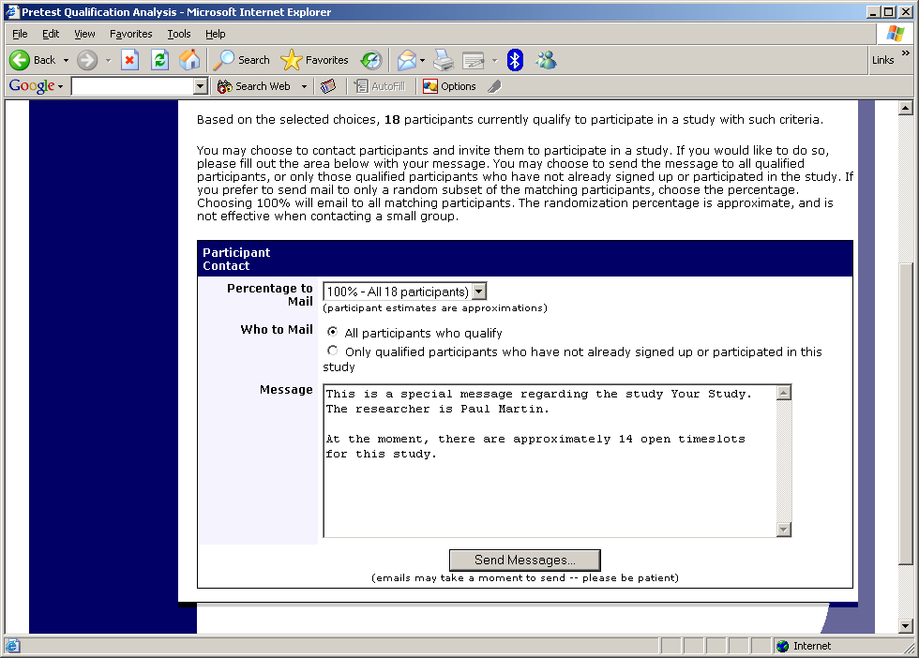
Figure 18 - Contacting Qualified Participants

Viewing Your Studies
To view your studies (and not the studies of others), choose the My Studies option on the top toolbar. The system will list all your studies in alphabetical order by study name, grouped by studies that are active, then inactive studies.

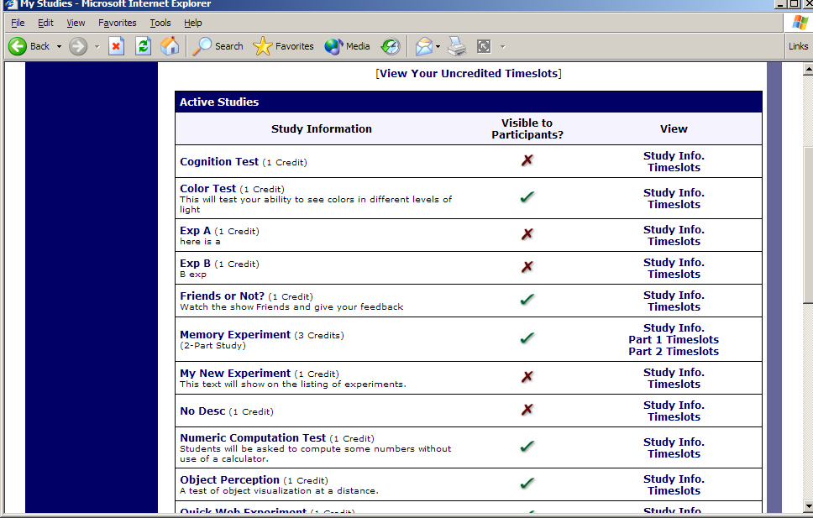
Figure 19 - Your Studies

Participant Study View
If you would like to see how your study appears when participants view it, find your study and choose the Participant Study View option. This will show exactly how the study appears to participants, with the exception that when a participant views a study, next to each pre-requisite and disqualifier study (for a study) is listed a status indicator about whether they have met that requirement. In Participant Study View, the pre-requisite and disqualifier studies are listed, but there is no status indicator next to each study in the list.

If for some reason you think your study is not visible to participants, it may be due to various restrictions you have set on the study, like prescreen participation restrictions, such that few (or none) of the participants in the pool qualify. You can ask the administrator to use the Check Study Configuration tool (available to them when they view your study) to provide advice on why your study may or may not be visible to participants. Administrators there also have an option to type in a specific participant to see if that participant would qualify for your study.

Viewing Other Studies
To view all studies that are visible to participants, choose the All Studies option from the top toolbar.

You will see a list first of all Active studies. These studies will show up to participants on the list of available studies. The next group of studies (if there are any) is Inactive studies. These will not show up on the list of available studies (to participants), but participants can access information about these individual studies on links from the page with their progress (if they participated in the study) or if another study has the Inactive study listed as a pre-requisite or disqualifier.

Online Survey Studies

Introduction
The system includes a rather extensive online survey feature (if enabled on your system). It allows you to set up an online survey as a study within the system, and participants who sign up for the study will be asked to immediately complete the survey. Upon their completion of the survey, they will be granted credit automatically by the system. You may then analyze their survey responses on an individual basis, or download the raw data across all participants who completed the survey, for further analysis. There is a slight chance that you may notice a discrepancy in the number of responses when analyzing a single question compared to downloading the entire set of responses. This can occur if a participant is currently taking the survey, but has not completed it. Their data is included in the single-question analysis (when available) but not in the full download of responses, as there is not a full set of data for an in-progress participant. The system will prevent participants from completing the survey more than once, so there is no risk of duplicate entries for the same participant.

To comply with research ethics guidelines, the participant is given the opportunity to withdraw from the survey at any time. If they withdraw, they are taken to a form where they can submit any comments (this is optional), and their withdrawal is then noted and all their responses are deleted. The researcher receives an email when this occurs, with some other information, including how much time was spent on the survey, and how many questions were answered. You should then grant credit to the participant as appropriate.

There is a space to provide closing text for the survey, which is displayed to participants after they successfully complete the survey (after they have saved all their responses and cannot go back). This is an ideal place to include any relevant debriefing information.

The online survey feature is rather complex due to the many features it contains. In addition, your ability to modify the survey after participants have started to take the survey is quite limited. Because of this, you should plan out your survey well in advance, to make sure it is finalized before you make it available to participants. Do not hesitate to contact the administrator if you have any questions. You may find it helpful to plan out the survey on paper before entering it into the system.

A survey may have an unlimited number of sections and an unlimited number of questions per section, though we recommend limiting surveys to fewer than 300 total questions and 15 sections, to reduce participant fatigue. This can be an issue since they must complete the survey all at once. The system will make participants aware that their session may time out because of inactivity, in cases where the survey contains many sections that have more than 15 questions (since participants are likely to spend a lot of time on those sections and thus risk being logged out for inactivity).

Questions may be free-entry (requiring the participant to type in an answer) or multiple-choice (pick only one or pick many from the list of choices). You may also specify that the system computes a participant’s results for an entire section, as either a section sum or average score. This computed sum or average can be computed only for numeric, multiple-choice (pick only one) questions in the section. Such a computation is often useful when a participant’s aggregate score is more important, such as with a depression battery.

For free-entry questions where the participant is asked to enter a free-form text answer, the size of the entry field (as it is displayed) cannot be resized in terms of dimensions (only by length). Participants may enter up to 255 characters in their response.

Sections can be displayed in a specified order or random order, or a combination of both. Every section may contain introductory text introducing the section, and the survey itself may also have introductory text introducing the survey, as well as closing text that is displayed upon completion of the survey. You may specify that questions within a section are displayed in random order. If you do not specify random ordering for questions in a section, then the questions will be displayed (in each section) in the order they were entered and cannot be reordered later. Multiple choice questions can have their choices displayed in the entered order or random order (this is specified on a per-question basis). Multiple choice question choices can be displayed horizontally (across the page) or vertically (down the page).

Note that there is a bug in Internet Explorer 5 on the Macintosh platform that may result in a slow response for participants when they are using this specific web browser/computer combination and completing survey sections with many questions and many choices. Microsoft has discontinued support for Internet Explorer on the Mac, so this bug will not be fixed. The other browsers on the Macintosh platform (Firefox, Safari, and Mozilla) all work perfectly, and there are no problems for Windows users with any browser. The specific problem occurs only rarely, but can occur. In general, any popular web browser released since 2005 should not have any problems.

It is important to realize that while the survey feature is quite extensive, there are some things it does not support. It cannot do timings, where the speed of a participant’s response (typically in milliseconds) to each question needs to be measured. It also cannot do branching, where the questions being presented to a participant will vary depending on their answer to other questions within that same survey (an example being asking a question like “Do you smoke cigarettes?” and then presenting a different set of questions based on their response). The reason advanced features like this are not currently supported is that our software is primarily a subject pool software product that happens to have an online survey feature within it. We asked our customers which features in an online survey were most important to them, and those features exist within the product. There are numerous products on the market specifically for doing online surveys (with no subject pool component), which contain more advanced features, and can easily be linked to from the Sona Systems product by setting up your study as an online study conducted outside the system.

Creating or Modifying a Survey
To create a survey, first create an online survey study. After you create it, you will see the option Update Online Survey when you view the study information. You may not create 2-part online survey studies.

It is important to note that while you are making changes to a survey, it is deactivated so participants may not participate in it. When you go to the Finalize Survey option after you have finished your work with the survey, you will have the opportunity to save your changes and make the survey active (available to participants) or inactive (not available to participants). You should always choose the Finalize Survey option when you finish your work with the survey, as the system saves all changes and computes some other important data when you finalize the survey. If you would like to continue work on the survey at a later date, you should still choose the Finalize Survey option to ensure your changes during the current session are properly saved (most likely you would choose to keep the survey inactive in this situation).

General Survey Information
Choose the General Information option (if creating a new survey, this is the first page you will see) to provide some basic information about the survey. The fields are explained below:

Field | Description
Introductory Text | Optional, maximum 10,000 characters. Provide a set of text that will be displayed when a participant starts the survey. You may include HTML in this area, but please be sure you know what you are doing. If you would like to add a carriage-return (paragraph break), simply type in “<p>” (without the quotes). When you first create the online survey, the system will automatically insert some basic default text in this area. You may change any of this text as much as you like – the system will not change it back later as long as you save your changes.  This is a good place to place any text for informed consent purposes. You may view how this text is displayed to participants by saving it, then going to Preview Introductory Text, which is available from the Section List page.
Closing Text | Optional, maximum 7,000 characters. Provide a set of text that will be displayed after a participant completes the survey and saves their responses. This is an ideal place for debriefing information. You may include HTML in this area, but please be sure you know what you are doing. If you would like to add a carriage-return (paragraph break), simply type in “<p>” (without the quotes).  You may view how this text is displayed to participants by saving it, then going to Preview Closing Text, which is available from the Section List page.
Display sections in random order? | You may specify a specific ordering for sections, have the system randomize the order for all sections, or specify the order of some sections, and a random order for other sections. If you specify the order for only some sections, you may also specify, for each section, whether it should be displayed before or after the random-ordered sections. The system does not keep track of the random ordering for sections for each participant.
Participant response review/change | If set to Yes, then participants may review and change their responses just before they complete the online survey. They are given this opportunity after they complete the last section of the survey, and before any closing text is shown. At this point, they can see all their responses and go back to any section to change their responses. Once they complete the online survey, they cannot go back at a later date and change any responses.  It may be useful to set this option to No (so that they are not allowed to review or change their responses at the end of the survey) if sections are somehow dependent on one another, such that allowing participants to change their responses may affect the integrity of data collection.

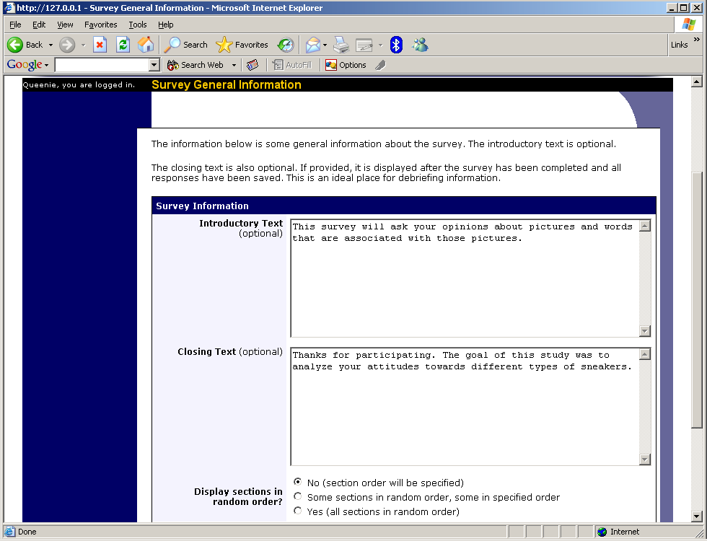
Figure 20 - Survey General Information

Section List
Depending on if you are adding or editing the survey, you will be taken to the list of sections for the survey. Here, you can change the order that sections will be displayed (if you have not enabled full random section ordering for the survey), and see a quick review of each question. From here, you can add a question to any section and edit any question. To add a new section, choose the Add a New Section choice at the bottom of the page.

If you have enabled partial random section ordering, then you can specify a section order for the sections you would like to be displayed in a specified order. For the sections you would like to be displayed in random order, leave the Section Order area blank. When you specify a section order, use each number once, and use the numbers 1-98 if you would like the section to be displayed before the random-ordered sections, and the numbers 100-199 if you would like the section to be displayed after the random-ordered sections. Be sure to use each number only once, or leave the number blank to make the section part of the random-ordered section. Sometimes it is useful to use partial random ordering if you want to ask basic (e.g. demographic) information in the first few sections, while asking more analytical questions in the random-ordered sections. Likewise, you may want to ask about the previous random-ordered sections after they are completed. It is not possible to intersperse ordered sections within the set of random sections, like having 2 ordered sections, then 3 random sections, the 1 ordered section, then 2 random sections, etc. The random sections are treated as an entire block of sections, and other sections cannot be placed at specific places within that block.

There is also a Preview Section option so you may preview the survey as participants will see it.

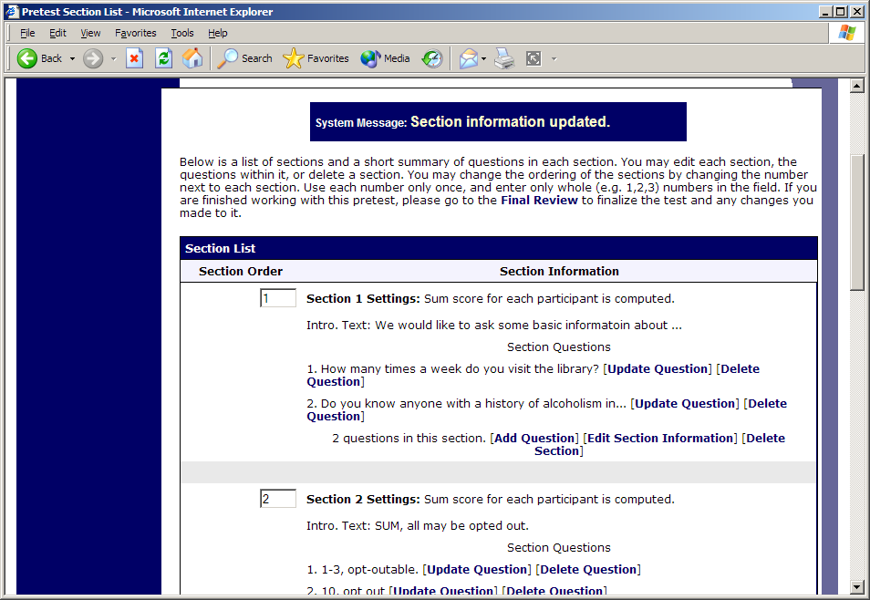
Figure 21 - Survey Section List

Adding or Modifying a Section
To add a new section, choose the Add New Section link at the bottom of the Section List page. To modify an existing section, choose the Edit Section Information link next to the section you would like to modify, from the Section List page.

There are three pieces of information you may provide for each section. First, you may specify some introductory text to be displayed at the beginning of the section. When participants take the survey, they view one section at a time, and all the questions in that section. The introductory text may be helpful in explaining the purpose or topic of the questions in that section. You may include HTML in this area, but please be sure you know what you are doing. If you would like to add a carriage-return (paragraph break), simply type in “<p>” (without the quotes). The introductory text is limited to 15,000 characters.

You may choose if the questions for that section are displayed in random order or the order in which they are entered.

You may also choose to have the system compute a section sum or average (for each participant) for the section. These scores are computed only for all the multiple-choice, numeric questions in a section. Think carefully about setting this value, because you are very limited in your ability to change it after participants have started to take the survey.

Computed section sums or means are often useful when all the questions are using a unidimensional scale (1-5, for example), but a participant’s average score response to the section is more useful to account for their outlier responses.

Depending on if you are editing or adding a section, after you save your changes, you will be taken to a page to add a new question or to the section list.

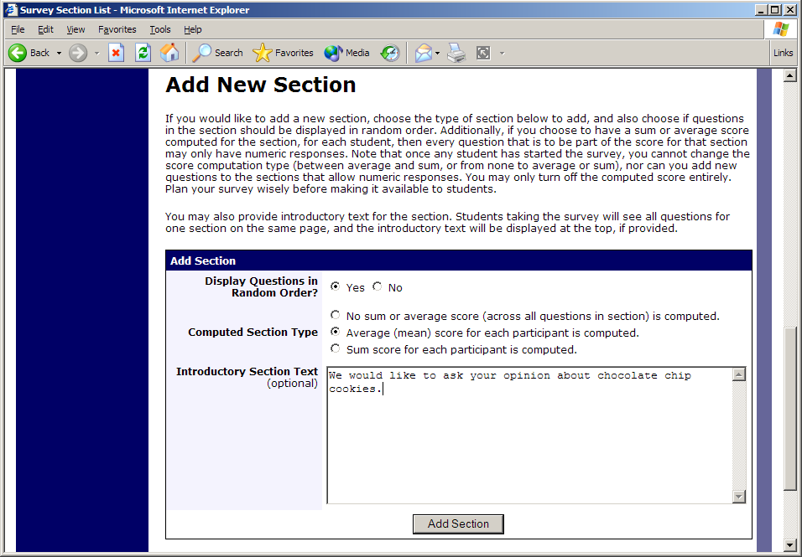
Figure 22 - Add New Section

Adding or Editing a Question
To add or edit a question, choose the appropriate choice from the Section List, next to the desired section. Questions will be displayed in the order they are added to a section, or in a random order, depending on the section settings. Questions cannot be reordered after they are added, so this should be planned carefully. Depending on the state of the section and if participants have taken the survey, some options will be automatically set for you, and not changeable. All fields must be filled out.

Field | Description
Question Text | The text for the question. This will be displayed above each question’s choices. Maximum 15,000 characters.
Abbreviated Question Name | A 15-character label for the question. This is not displayed to participants and is used to name the columns that appear when the data is exported in CSV format. Many statistical analysis programs limit column names to 15 characters.
Question Type | Multiple Choice (select one), Multiple Choice (select many) or Free Entry. If the section has a computed average or sum, you may be limited in your ability to add Multiple Choice (select one) non-numeric questions. Free entry choices may contain a response up to 255 characters in length.
Display length of Free-Entry field | Specifies the length (size) of a free-entry field when it is displayed. Acceptable values for this setting are 5-85, and the field will always allow participants to type in up to 255 characters. The height of the field cannot be adjusted, and this setting only applies to Free Entry questions.
Display choices in random order? | If set to Yes, the choices for this question will be displayed to participants in a random order. This option only applies to multiple choice questions.
How should the choices be displayed? | Horizontal (across the page) or vertical (down the page) are the two options for how the choices for a multiple-choice question should be displayed. Often, the horizontal display is effective when the question involves a scale. This setting applies only to multiple-choice questions.
Can participants decline to provide an answer for this question? | If set to Yes, participants will see a choice below this question that allows them to opt out of answering the question. If set to No, they must answer the question. The default when adding a new question (not copying an existing question or section) is set to Yes for ethical compliance.
Are all choices numeric? | If set to Yes, all choices must be numeric whole numbers (e.g. 1, -2, 10). This only applies to multiple choice questions. Sections with a computed section sum or average may not contain non-numeric multiple choice (select many) questions.
Display numeric value? | If set to No, the numeric value of the choice is not displayed to participants. This only applies to numeric, multiple-choice questions where each choice includes both a numeric value and associated text (e.g. “5 Strongly Agree”). This is useful when running a reverse scale.

If the question is a multiple choice question, you must also fill out the choices section that is part of the same form. A minimum of 1 choice must be provided for the question. Each choice may be up to 255 characters in length. If the question is specified as numeric, you must provide a numeric choice, and that choice must be a whole number (e.g. -5, 1, 0, 349). If you would like to provide descriptive text to accompany each numeric choice, you may do so by typing in the numeric choice and leaving one blank space after it, then typing in the descriptive text, for example: “5 Strongly Agree”. If you provide descriptive text along with the numeric choice, then you have the option of hiding the numeric value from participants, by choosing No to the “Display numeric value?” setting for the question. This is useful in reverse scale or other situations where the numeric value for the choices is not important.

If the choices you specify when adding a question do not conform to the conform to the configuration of the question (e.g. specify a non-numeric choice for a numeric question), the system may change the question configuration to ensure that the choices are then valid.

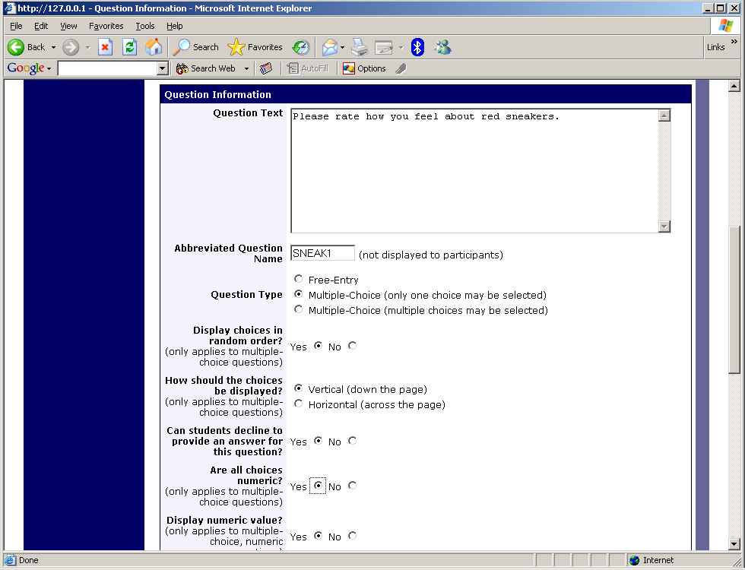
Figure 23 - Edit a Question

Copying a Section
You may copy a section from any of your own surveys into your current survey, by choosing Copy From an Existing Section in the Section List. You will see a list of eligible surveys to copy from. After you choose which survey to copy from, you will see a list of eligible sections in that survey. Once you choose a section, it will be copied into the survey you are currently editing. You may copy only one section at a time, because of the system performance impact when copying sections.

The administrator also has the ability to copy to or from the prescreen, so ask the administrator to do this for you, if you need it done.

Copying a Question
For multiple-choice questions, it is often the case that many questions have the same measures (choices). To make entry of similar questions easier, you may use the Copy Question feature to copy a question. Such an option is only available for multiple choice questions. To copy a question, select the question you would like to copy (when viewing the Section List). You will then be taken to a list of sections where you may copy this question to (the default is set to the section the question came from). After you decide which section you would like to copy the question to, you will be taken to a page where you can make any final changes to the copy of the question before saving it.

Saving Your Changes
When you are done, you should go to the Final Review and save your changes. Even if you plan to do further editing of the survey later, it is imperative that you go to the Final Review step, as the system needs to save certain special changes and make some computations. If you do not want participants to participate in the survey yet, you can save changes but keep the survey inactive. When you save your changes, it may take a moment to save all the changes, as the system is performing a number of computations on the survey. Please be patient, as these computations are done to make performance for participants as fast as possible. The system tracks which user last made the survey active or inactive and when they did this, and this is displayed on the setup page.

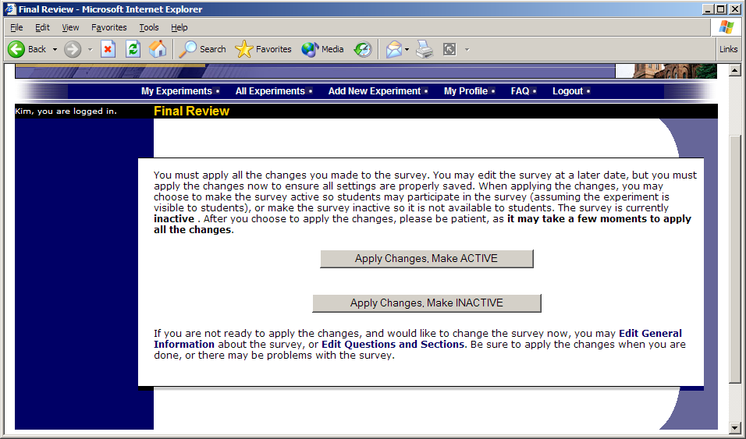
Figure 24 - Saving Survey Changes

Viewing a Survey as a Participant
If you would like to see how the survey will be displayed to participants, that can easily be done while setting up the survey. Next to each section (in the section list), there will be a Preview Section link so you can view the section exactly as participants would see it. You may also view how the introductory and closing text will appear to participants, by choosing the Preview Introductory Text and Preview Closing Text options which appear on the Section List page.

Participants will see a basic progress display on the top right corner of each page, listing the section they are on (ordinal counting), and how many sections total are in the survey. When using Preview Section, you will see this progress display as well, except the current section number will appear as “X” in preview mode since it is not an actual participant taking the survey (and randomization of section order may be involved).

If you find it necessary to go through the entire process as a real participant, you can do so by creating a test participant account. Set the online survey study so it has an invitation code, so no other participants can sign up (since they will not know this invitation code). Then, sign up with your test participant account and take the survey. You can remove the invitation code later if necessary.

Participant Withdrawal from a Survey
At any time while participating in the survey, participants have the option to withdraw from the survey. A Withdraw button will appear in the top right corner of each page.

When a participant withdraws, they have the option to withdraw without the option to receive credit, or with the option to receive credit.

If they choose to withdraw without the option to receive credit, all their survey responses as well as the record of their sign-up will be deleted. Participants are told that this option should be used if they want to later participate in the survey. In other words, it would likely be used when a participant starts a survey but realizes they won’t be able to complete it at the moment, but would like the opportunity to participate later. No notification to researchers is sent in this scenario.

If they choose to withdraw with the option to receive credit, then all their survey responses will be deleted, but a record of their sign-up will be kept and it will be in awaiting action state. The researcher will receive an email about the withdrawal, as well as some basic information about how far along the participant was when they chose to withdraw (both in time and number of questions). This information is provided as some schools have a policy of granting credit for early withdrawals based on time spent or percentage completion. Participants also have the option of including a message that will be sent to the researcher to explain their withdrawal, but such a message is not mandatory. The researcher should then grant credit to the participant if necessary, by going to the timeslot and finding that sign-up.

Participants are informed that if they are unsure which of the withdrawal options to choose, that they should choose the withdraw option that retains their ability to receive credit.

The withdrawal option cannot be removed, as it is there to ensure compliance with research ethics guidelines.

Viewing Survey Data Usage and Deleting Survey Data
The system has a limited amount of storage space, and you are expected to download the survey data you have collected on a routine basis, and then delete it from the system. By going to View Survey Data Usage, you can see how much database space is being used. You can then download the survey data (a link is provided), and delete it from the system.

When you delete the data from the system, all survey data collected within the last 5 minutes will not be deleted, as a safety feature. This is to ensure you have had adequate time to download the survey data before deleting it.

If you choose to delete the survey data in this manner, the record of participant sign-ups will be retained, so you can ensure they do not complete the same online survey again.

Deleting a Single Participant’s Survey Responses
On rare occasions, you may want to delete a participant’s survey responses, usually so they can participate again. To do this, cancel their sign-up and that will delete their responses. Note this will also remove any credit they earned. See Manual Cancellation for more information.

Analyzing Survey Responses
You may analyze a specific survey question on-screen by selecting the survey and choosing the Analyze Survey Responses option. From there, you may choose a specific question and view or download the response data. This will include data from participants who are still in the process of completing the survey, but have not yet completed it. The Download Survey Responses option, which provides the entire set of survey responses for all participants, includes only data from participants who have completed the survey, to ensure easier data analysis.

In rare cases, you may notice that a few responses for certain questions appear (or disappear from) the Analyze Survey Responses while never showing up in Download Survey Responses. What happens in this situation is that a participant started an online survey but never fully completed it or withdrew from it (they probably just closed their web browser). The system goes through all “orphaned” responses in this situation and clears them out once they are more than 2 days old.

More likely, you will want to analyze the survey data across all questions. In this case, you should choose the Download Survey Responses option.

To successfully analyze the data, you will need to download 2 sets of data. The first is the question key, which lists a unique numeric identifier for each question, along with the question text and abbreviated question name. It also includes the section number each question was in. Note the section number listed is merely a unique identifier for each section, and has no correspondence to the order in which sections were presented. Also note that section mean and sum values, if calculated, will normally be at the end of the list of questions. This data is in CSV format, and is available by clicking the Download Question Key link on the Download Survey Responses Page.

After you download the question key, you can download the survey data. The system may require that you download the data in sections if there is too much data to be downloaded as one file.

There are three options for downloading and viewing the data (both the question key and responses):
- Download as CSV File. This is the most popular option, and allows you to save the data on your computer and load it in your preferred data analysis tool.
- View On-Screen (CSV Format). This option lets you view the data on-screen instead of downloading it. The data is still displayed in CSV format, and it’s a good way to view the format of the data and ensure all the data you expect is there. Often with larger datasets, downloading and viewing the data with some tools (like Excel) may make it appear as if not all the data is there, when in reality it’s a limitation of the tool and not a problem with the data download. The on-screen option is also useful if data was collected in a language that uses Unicode character sets, like Hebrew.
- View On-Screen (Table Format). This option provides an easy way to view the data on-screen (to visually analyze the data) but is not very useful for purposes of loading the data into an analysis tool.

The data is presented as one row per respondent, with each of their responses in a different column. The first row includes the column headings, and the column heading maps to the abbreviated question name. Since there is no facility to specify an abbreviated question name for the computed section sum/mean item, the system automatically assigns a unique name to those columns. The naming convention is SECXXX where XXX maps to the system’s internal section identifier for that section (section_id). You can use the question key to determine which question maps to which column. The data also includes the exact time the participant started and completed the online survey. You can use any common data analysis tool to compute how long it took the participant to complete the survey, using this information. There is also a column listing how many minutes it took the participant to complete the survey, rounded to the nearest minute.

There will be an option to include only the numeric response portion of questions that are multiple-choice with numeric choices. This is useful if the numeric question was set up with associated text, but that text should not be included in the analysis file. One example would be where the response selected was “5 Strongly Agree” but only the number 5 (and not the associated text) is useful during analysis. If you choose this option and download data and find that the associated text is included with the numeric response, then have a closer look at the survey – most likely the question was not actually set up as a numeric question. The easiest way to deal with this downloaded data is to use a data analysis tool to do a search and replace to change the response in your downloaded data into a numeric format. Your IT department can provide assistance with such tools.

If your survey has a lot of questions (and thus columns in the output file), you may have trouble loading the data with some spreadsheet programs, which are not equipped to handle such large datasets. Your best option is to use a full-feature statistical analysis packages, like SPSS or SAS. Those packages handle large CSV-format data imports with ease. Your IT department can help you to select the best tools. In particular, Excel has trouble dealing with datasets with more than 250 questions (columns).

Frequently Asked Questions about Online Surveys

Is it possible to have multiple versions of an online survey, with participants being
randomly assigned to one version of the survey at the start of the survey?

The best way to do this is to create multiple online surveys (you can easily copy questions between them with the Copy Section Feature, to save time), and use a prescreen participation restriction that is unrelated to your research. For example if there is a prescreen question asking for the last digit of the participant’s university ID number (assuming this is randomly distributed), then you can use that to easily break up the pool into random tenths by using that as a prescreen participation restriction for each version of the study.

Is there a way to post images, graphics, or videos in the online survey, so that participants can respond to questions referring to the image or video?

Yes. You will need to have the ability to post images on a webserver (most likely at your school), and know a small bit of HTML. Let's say your graphic is located at http://www.yourschool.edu/myimage.gif

Put this in the place where you want the image to be displayed:
<IMG SRC="http://www.yourschool.edu/myimage.gif">

If you're unfamiliar with HTML, you may want to ask someone in your IT department for assistance with this.

You can use a similar process to post videos, but you'll need to ask the person in charge of the webserver where you post the video for the best method (in HTML) for linking to it, as there are a few different methods to link to videos.

You cannot upload images or videos directly onto the Sona Systems server, but every university provides a facility to post content on webservers at the school, and this method is better for participants also as the data (images and videos are usually quite large) will be stored on the high-speed network within the university.

Can certain sections be presented for a specified period of time (e.g. 60 seconds)?

No. There are technical limitations and inaccuracies in how web browsers interact with web servers, as well as internet latency, that make this difficult to do, so this feature is not offered.

Can I make an online study a two-part study?

Online studies cannot be two-part studies, and the reason has to do with what two-part studies are intended for. They are used when the researcher needs to ensure a fairly strict separation between each part. For example, in memory research, a researcher may want to set up the two parts exactly 14 days apart.

The issue with online studies is they are not scheduled to take place at a certain date and time, so it's impossible to enforce any kind of strict separation between each part.

If the goal is just a follow-up to a study, then the time separation probably isn't very important. In that case, the solution is to set up two studies, and set the first study as a pre-requisite for participation in the second study.

Is there a method to upload a survey into the system (from Word, Excel, etc.)?

For online survey studies, there is no method to upload the data. We considered this, but there is no standard format for survey data representation, so there was no format we could really support for uploading.

In the online survey feature, there is the ability to copy questions and sections, which may make it easier to set up the survey if many questions have the same sets of choices, for example.

When a participant is taking an online survey study, when is their sign-up actually recorded in the system?

The system will not record completion (or even sign-up) of an online survey study until it is actually completed (or if the participant chooses to withdraw early). Participants are shown the closing text as the last step of the online survey study -- just after their responses have been saved and their sign-up is recorded.

When they start the online survey study, it is noted to participants that their responses are not fully saved until they complete the study, and only then will they be properly recorded. This is for both technical and IRB reasons.

I have created my online survey and participants cannot see it. I have ensured that all the prescreen restrictions, course restrictions, and pre-requisite/disqualifier restrictions are set correctly. Why is it not showing up?

You need to set up at least one timeslot (and the standard method for an online survey is to set up only one timeslot) for the survey, to specify the participation deadline. If you still have problems, contact the administrator and ask them to run Check Study Configuration on your study, and that will explain why a study is or is not showing up.

My online survey had 5 spaces in a timeslot, and somehow 6 people signed up and received credit. How did this happen?

This is a rare situation that occurs, usually with online surveys that take a long time to complete. What happens is that all 6 people (or at least the last 2 people) started the online survey at around the same time, and before any of them could finish it. The system checks at the point of sign-up to see if there are open spaces for the online survey, but does not consider someone who has started the online survey but not finished it as taking up one of those places (in case that person abandoned early without properly withdrawing). So, in this rare situation, there is no choice but to credit all participants who successfully completed the survey, as it is the only fair outcome for participants. Note that this situation is quite rare, and most likely occurs when the survey is lengthy, and there are many participants vying for a limited number of available timeslots in the system.

Working with Timeslots (Sessions)
Timeslots (also referred to as Sessions) are the available times when a participant may participate in the study. If you are setting up timeslots for a web-based study, please read the section in this documentation on Web-Based (Online) Studies for some special information.

Timeslots allow you to specify a date, time, location, maximum number of participants, and researcher for a session.

Timeslot Usage Restrictions
If enabled on your system, you may find there is a limit to the amount of time available for scheduling timeslots. This usage is computed by adding up all the past timeslots where credit was granted, and then adding all timeslots in the future, regardless of credit status. You may find that the usage goes down over time, as time progresses and timeslots that were in the future had no participants signing up for them. The usage and limit is listed whenever you add a timeslot, if usage restrictions apply. It may also be listed when you view your profile, depending on how your system is configured.

Timeslots Linked to Specific Researchers
If your system is configured to allow multiple researchers per study, you will also have an option to link timeslots to a specific researcher. This is done primarily for organization purposes, and has no effect on who can view and modify the study, or any timeslots for that study.

This feature is useful when there are a number of researchers running a study, and researchers are responsible for running specific timeslots. If a timeslot has a specific researchers linked to it, then only that researcher will be listed as the contact point when a participant receives any emails related to their participation in that timeslot. Finally, only the researcher connected to that timeslot receives related notification emails, such as participant cancellation notification, and reminder emails (assuming such emails are enabled).

It is also possible to have some timeslots where a specific researcher is linked to them, and others where all researchers (who are assigned to the study) are responsible for the timeslot. It is not possible to link more than one, but not all of the researchers (for the study), to a specific timeslot. The options are to either link one researcher to the timeslot, or all of them.

If a researcher is removed from a study, then any timeslots that were linked to them for that study will be changed so all researchers (for the study) are now responsible for those timeslots.

To use this feature, the system must be configured to allow multiple researchers per study. Then, the study itself must be configured to allow researchers to be linked to specific timeslots. Finally, the study must have more than one researcher connected to it.

Creating Timeslots
To add a timeslot for a study, you must first choose the study that you would like to add a timeslot for. To view your studies, choose the My Studies option on the top toolbar. Click on the desired study, and choose the Timeslots choice.

You will see a list of any existing timeslots, and the Add A Timeslot option at the bottom of the page. Click on Add A Timeslot.

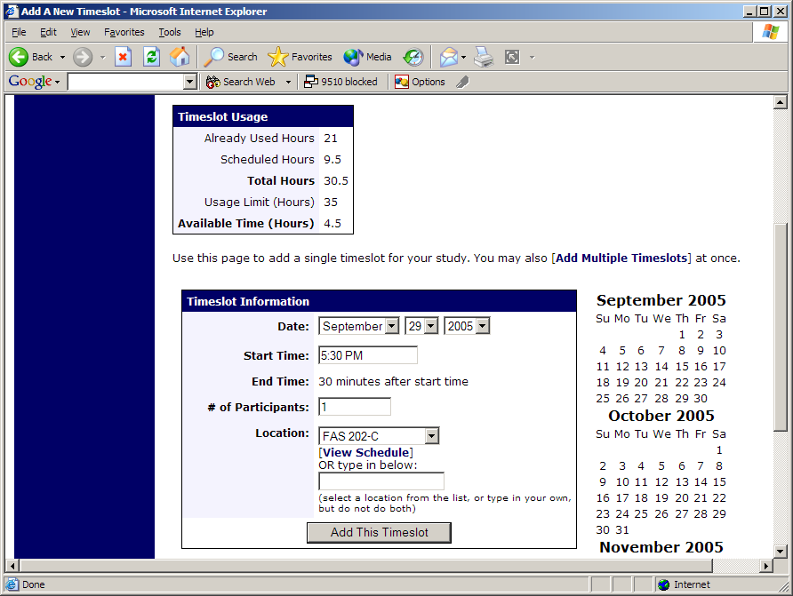
Figure 25 - Adding a Timeslot
The following table lists the information you may enter about a timeslot, along with an explanation. All fields are required.

Field | Explanation
Date | The date for the timeslot.
Start Time | The time for the timeslot. A sample time will be provided. If you want to change the time, please use the same format as the time you see presented. Note in particular how “a.m.” and “p.m.” are handled (if such a format is enabled on your system).
End Time | The time when the timeslot will end. This is computed automatically based on the duration you entered when you set up the study.
# of Participants | The number of participants for this timeslot. This limit is not visible to participants. They will only see whether the timeslot is full or not. The maximum number is 999.
Location | The physical location where the study will take place, for this timeslot. It will be automatically filled with the location of the previous timeslot, when available, to ease in data entry.  Depending on how your system is configured, you may see a list of pre-configured locations. You may choose any of those locations and click on View Schedule to see the schedule for a location. The system will automatically prevent you from adding a timeslot using a location that is already in use at the time you try to schedule the timeslot. If you do not see the location in the list that you plan to use, you can simply type in the location in the text field below it.  The location field does not apply for web-based studies.
Researcher | The researcher assigned to this specific timeslot. The list will contain a list of all researchers for the study. Choose ALL if all researchers (for the study) should be assigned to this timeslot. See Timeslots Linked to Specific Researchers for more information.

To ease data entry, the system will automatically fill in the date, time, and location based on the ending time of the last timeslot for this study. If applicable, your current timeslot usage will be listed, and you will be prevented from adding a timeslot that would exceed your timeslot usage time limit. A convenient calendar is provided next to the form, and you can click on any date and that date will be transferred to the form.

If you add a timeslot such that there is another timeslot (for any study) that occurs in the same time, at the same location, you will receive a warning (but the addition will be allowed). If you add a timeslot that will take place outside of normal hours (for example, at 1:00am), the system will provide a warning but will allow it to be scheduled. You may not schedule a timeslot to occur after the IRB expiration date for your study, if Strict IRB mode is enabled by the administrator. The system allows adding timeslots to a study that is not available to participants (not active or not approved), but it will give a warning because participants are not able to sign up for the timeslot.

If you are running a web-based (online study), you should create a single timeslot with the participation deadline equal to the last day you would like to run the study. For number of participants, specify the maximum number of participants who may participate. If you are running a web-based study and you plan to collect data from more than 999 participants (999 is the maximum allowed in one timeslot), then once that timeslot is close to filling up, create a second timeslot as a slightly different time and/or date as the first timeslot.

Creating Multiple Timeslots
If you would like to add multiple timeslots at once, choose the Add Multiple Timeslots link. You may choose to add a specified number of timeslots, or copy the timeslots from another week to a specified week. If you choose to copy, the system will copy the time, location, and number of participants for the specified week to the desired week, for each day of that week (starting with Monday).

If you choose to create a specified number of timeslots, you can choose the number of timeslots you would like to add, the start time and date, and the amount of time between each timeslot (to allow for breaks). You also may specify that timeslots that would occur outside normal business hours be shifted to the next business day, and specify when business hours occur. The system considers Monday-Friday to be business days.

On the subsequent page, you may change any of it to deal with special cases. Timeslots that you attempt to add, that either have errors or would result in exceeding the timeslot time usage limit, will not be added. This feature is not available for web-based (online) studies, as web-based studies rarely have more than one timeslot.

If you would do not want to add a specific timeslot that is listed, choose No in the Add This Timeslot? Column.

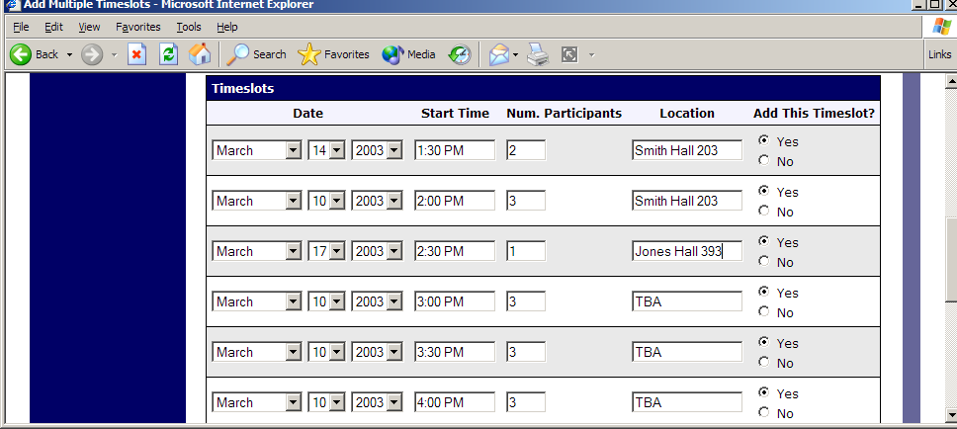
Figure 26 - Creating Multiple Timeslots

Modifying and Deleting Timeslots
To modify or delete a timeslot for a study, you must first choose the study that you would like to deal with. To view your studies, choose the My Studies link from the top toolbar. Choose the Timeslots option in the timeslots column for the desired study. You will see a list of all recent timeslots. Recent timeslots in the past with no participants signed up will not be displayed. To work with timeslots more than a few days old and to see all timeslots, you will see a link to view all timeslots for the study. Select the timeslot you would like to deal with, and click the Modify button.

If the timeslot has no participants signed up for it, you will see a Delete button. You may not delete a timeslot that has participants signed up for it. If you would like to delete the timeslot, click the Delete button, and you will see a confirmation page. Choose Delete again to delete the timeslot.

If you would like to modify the timeslot, modify the desired information and click the Update button just below the timeslot information. It should be noted that participants will not be notified (by email) of any changes you make to the timeslot, so you should contact them if information needs to be passed on to them (a link is provided on the same page to do so). If you change the date or time of the timeslot, you will be warned that this was changed in case the change was unintended. You may not update the size of the timeslot (number of participants) to a value lower than the current number of participants signed up for the timeslot. Generally, researchers only update timeslots with sign-ups to update the location, if it was not available when the timeslot was originally created.

If the study (or researcher) is subject to timeslot time usage restrictions, the system will enforce them and prevent you from increasing the number of participants in a timeslot if that would result in exceeding the timeslot usage limit.

Timeslot Change Tracking
The system automatically tracks certain changes that occur with a timeslot, including any time key information about the timeslot (date, time, etc.) is changed, as well as any time a manual sign-up or cancellation is performed (i.e., not a sign-up or cancellation done by the participant). This information is tracked for the last 3 months of changes for each timeslot.

To view this information, choose the View Timeslot Modification Log when viewing a timeslot, and you will see this information.

Deleting Multiple Timeslots
If you would like to delete multiple timeslots at once, you may do that as well. Such a feature is only available for timeslots which have no participants signed up. To do so, select the desired experiment and choose Timeslots. At the bottom of the Timeslots page, you will see a Delete Multiple Timeslots option. The option may not appear in certain cases where such an option is not available because of a lack of available timeslots to delete.

After going to that page, you will see a list of timeslots eligible for deletion. Choose the timeslots you would like to delete, and choose Delete Selected Timeslots to proceed. If you would like to delete all empty timeslots, there is a Select All option at the bottom of this page that will automatically select all timeslots listed on the page for deletion. Click the Reset button to revert the effect of choosing the Select All option.

The system routinely deletes all empty timeslots more than 3 months old to preserve database space.

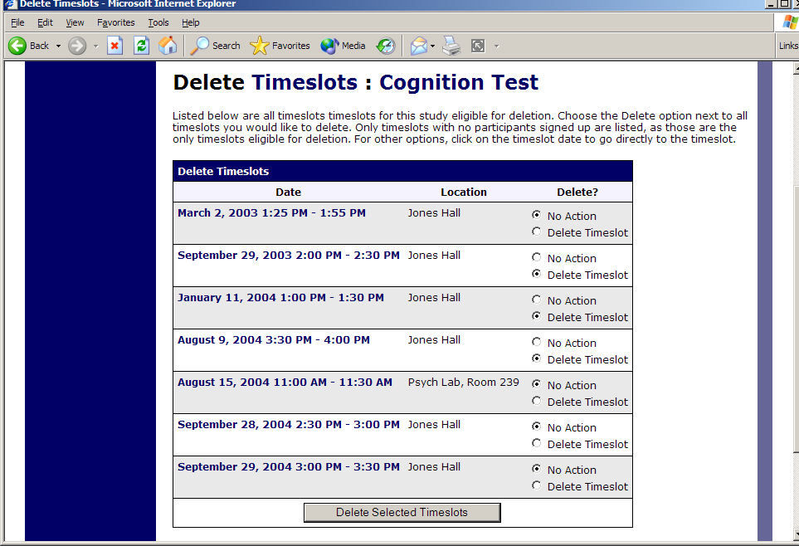
Figure 27 - Delete Multiple Timeslots

Manual Sign-Up
If enabled on your system, you may manually sign up participants for your study. There are a number of situations where this is desirable. If the participant happens to show up for a timeslot they were not signed up for, and you elect to let them participate, you can sign them up on the spot for the timeslot. The participant in many cases cannot sign up on their own in this situation, because the sign-up deadline has passed. You may also sign up a participant for a study that has already occurred, if necessary.

Also, a manual sign-up overrides any restrictions you have placed on the study (e.g. pre-requisites), though you will be warned if you are overriding any restrictions. You may not sign up a participant for the same timeslot that they are already signed up for. You are allowed to sign them up for a study even if they are already signed up for a different timeslot for that same study, though you will receive a warning in this case. You may not sign up a participant for a study if it would cause them to exceed their maximum credit limit. If it is necessary to do so, please ask the administrator to do this, as they are allowed to do a manual sign-up even when it will violate maximum credit earning limits.

If the system is configured as such, the participant will receive an email when you sign them up for a study. In that case, you are also given the option to enter comments to be included in this email that may better explain to the participant why they were signed up. You may only sign up participants for your own study.

To sign up a participant for a timeslot, you must first find the desired study and timeslot. To view your studies, choose the My Studies option from the top toolbar. Click on Timeslots for the desired study, then select the timeslot you would like to deal with, and click the Modify button.

At the bottom of the page, you will see a Manual Sign-Up option, if it is enabled. Type in the participant’s User ID (you may have to ask them for this) and click Sign Up. If enabled, you may also choose to sign up a participant using their unique ID code. You may also have the choice to enter their last name and choose from a list of participants. In all cases, after submitting the form, you will see a confirmation page that also lists any restrictions on the study. Choose Sign Up to complete the sign-up.

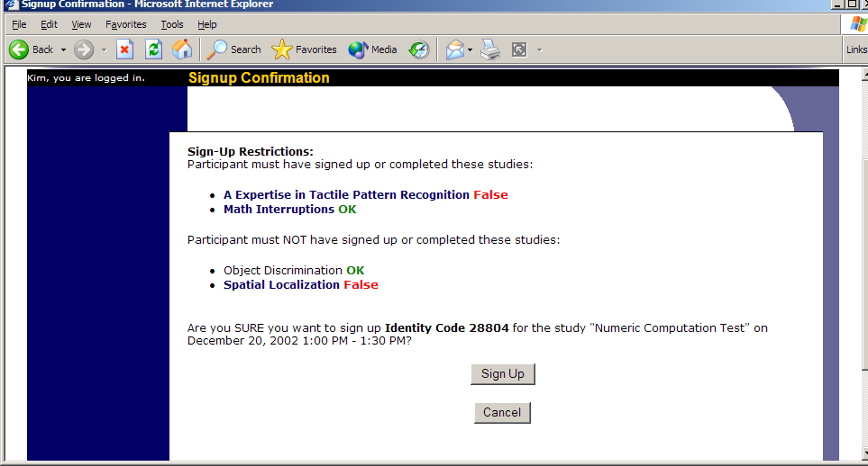
Figure 28 - Manual Sign-Up Confirmation
If you are subject to timeslot time usage restrictions, the system will enforce them and prevent you from signing up a participant in the timeslot if that would result in exceeding your timeslot usage limit.

If you are doing a manual sign-up for a two-part study, you must do a manual sign-up for each part separately. The system will overlook the scheduling range restrictions as well.

You cannot use the manual sign-up feature for online survey studies, because the sign-up for the study is integrated with the administration of the survey.

The manual sign-up feature will not appear for a researcher if the study requires approval by the administrator and it has not yet been approved. This is to ensure sign-ups cannot occur for a study that has not yet been approved, since research should not take place prior to approval.

Manual Cancellation
If enabled on your system, you may have the opportunity to cancel a participant’s sign-up. You may only cancel sign-ups that are in a No Action Taken state. To cancel a sign-up, find the desired timeslot and participant, and click Cancel next to their name. The participant will be sent an email about the cancellation (and who performed it), along with a confirmation code, and their sign-up will be immediately cancelled. The administrator may also receive a copy of this cancellation email, depending on how the system is configured.

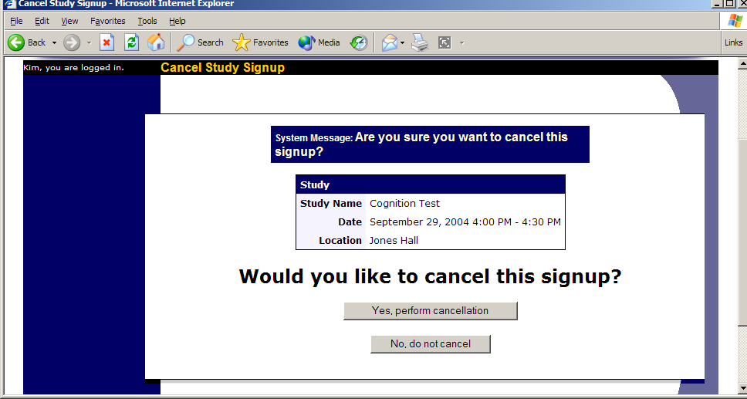
Figure 29 - Manual Cancellation

Viewing the Participant List
To view the list of participants who have signed up for your study, you must first select the study and timeslot you wish to see. To view your studies, choose the My Studies option from the top toolbar. Click on the Edit link in the timeslots column for the desired study, then select the timeslot you would like to see, and click the Modify button.

The list of participants, along with their email addresses, will be listed. If ID codes are enabled, you will only see an ID code and no name or email address for each participant, and the list will be sorted by ID code.

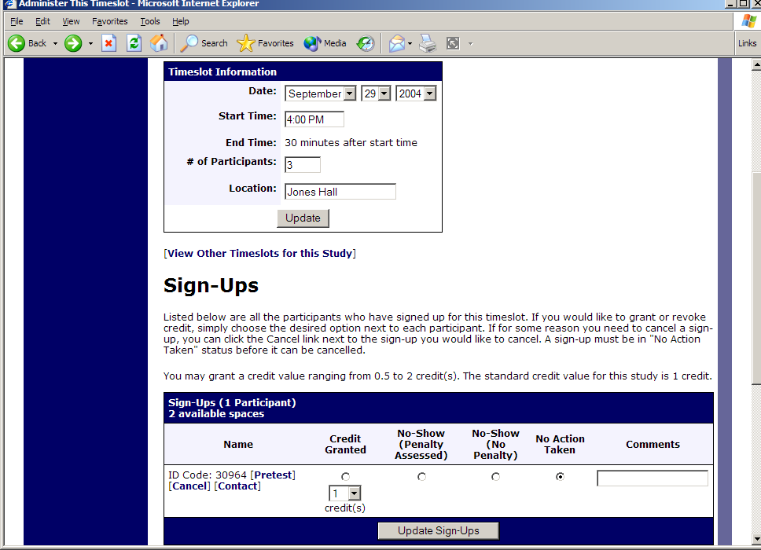
Figure 30 - Modifying a Timeslot / Participant List

Viewing Prescreen Responses
If online prescreens are enabled on your system, and you are also allowed to view an individual participant’s prescreen responses, then you will see a Prescreen link next to each participant’s name (or ID code) when you view the information for a timeslot. Click on that link to view the participant’s prescreen responses.

If you would like to download the prescreen data for all participants in your study, choose the Download Prescreen Responses option after clicking on your study. That will allow you to download all the data at once, in CSV (comma-separated) format, for further analysis. The download will not contain data for participants marked as a no-show.

If you would like to analyze responses in aggregate (across all participants in the system), see Analyzing Prescreen Responses in this documentation.

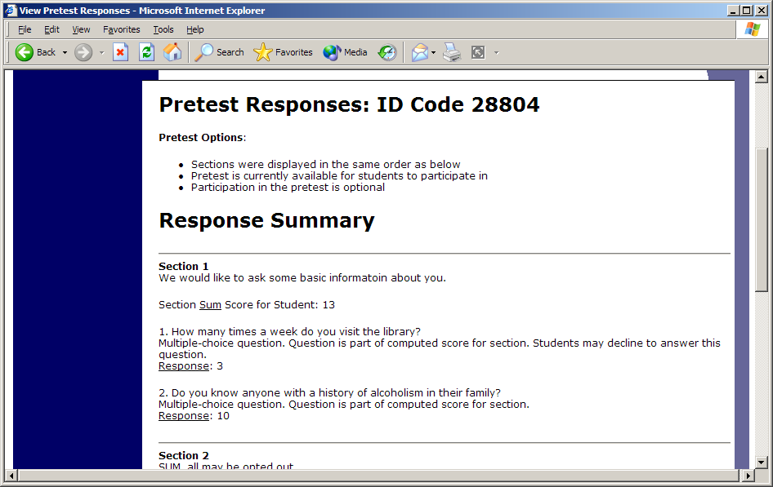
Figure 31 - Viewing a Prescreen

Granting or Revoking Credit
At the completion of a session, you should promptly deal with the participants, in the system, to ensure proper credit grants. The reason for the prompt handling of this situation is in the event your study is a pre-requisite for another study, and a few other situations. You do not want to hold up other studies that are waiting on your response to the study you just ran.

To grant or revoke credit for a timeslot, you must first find the desired study and timeslot. To view your studies, choose the My Studies option from the top toolbar. Click on the Edit link in the timeslots column for the desired study, then select the timeslot you would like to see, and click the Modify button.

You will see a list of participants, identified either by name or ID code. If the participant properly participated in the study, click the Credit Granted button next to their name (this text may appear as Participated if the study is set up for payment). If the participant did not appear for the timeslot, choose the Participant No-Show? button. Depending on how your system is configured, you may see two “No-Show” options. One option allows you to assess a penalty, and the other does not. Studies that are for pay only will always have only one type of No-Show option. You may choose not to assess a penalty if the participant had an acceptable reason for failing to attend the study.

Depending on how your system is configured, you may see an option to grant a credit value that is different from the standard credit grant. This is useful when you want to grant a participant a lower credit value because they left the study early (if they deserve a lower credit grant), or a higher credit value if the study ran longer than expected. The default value that is selected is the study’s standard credit value. If this is enabled, then you may also grant 0 credits. This is useful if you do not want to grant credits to the participant, but you also want to prevent them from participating in the study again. If a participant is granted 0 credits, and the study is set to prevent duplicate sign-ups, then the participant will not be able to sign up for that study again.

If desired, enter any comments about the session in the Comments section (generally, this is used to indicate the reason for denying credit). Participants will see anything you enter in the Comments section for their sign-up, and these comments will be included in the email sent to participants when a credit grant/revocation occurs, if notification emails are enabled on your system.

Click on the Update Sign-Ups button at the bottom of the list of sign-ups to save your changes. Credit will be granted or a penalty assessed as necessary. The participant(s) will be emailed about this if the system is configured in such a manner.

It is not recommended to leave any sign-up for a timeslot that has occurred in the “No Action Taken” stage. This is a credit “limbo” and the system will warn you upon your next login about the offending timeslot that has not been dealt with properly. Note that if Manual Cancellation is enabled and you would like to cancel a participant’s sign-up, the sign-up must be in No Action Taken state.

Depending on how your system is configured, the system may automatically grant credit to participants for timeslots that are more than an administrator-specified number of hours old, and where the researcher has taken no action. You can always change the automatic credit grant later if it was in error. The automatic credit grant takes place once a day, usually overnight. Your administrator can let you know if such a feature is enabled on your system.

If you need to do a simple credit grant across many timeslots, see the Uncredited Timeslots section which offers such a feature.

Batch Credit Granting
In some cases, you may wish to automatically sign up and immediately credit a group of participants. This is often useful if you administered a study on an ad-hoc basis, and you want to credit participants after the fact.

To do so, go to the appropriate timeslot (you may want to create a timeslot specifically for this purpose), and click on Modify Timeslot. In the Manual Sign-Up section (if enabled), you will see a Batch Credit Grant link. Click that and you can provide the list of User IDs of users you would like to sign up and credit. Users will be signed up and credited immediately. This feature overrides any sign-up restrictions on the study, just as a normal manual sign-up does.

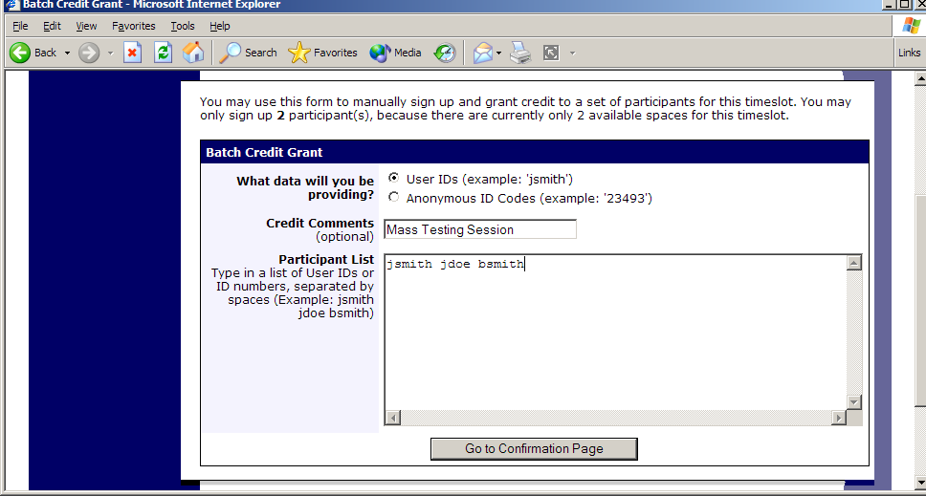
Figure 32 - Batch Credit Grant
The batch credit grant feature will not appear for a researcher if the study requires approval by the administrator and it has not yet been approved. This is to ensure sign-ups cannot occur for a study that has not yet been approved.

Emailing Participants
If you wish to contact participants in a particular timeslot for any reason, you may click on the Contact link that will appear next to each participant’s name (or ID code) to contact an individual participant. To email the group of participants for a particular timeslot, click the Contact All Participants choice at the bottom of the Modify Timeslot page for that timeslot.

You will be taken to a page where you can fill out a message that the system will send to the selected participants. The message is auto-filled with some basic information about the study, so participants are aware of which study you are referring to. You may remove this information if desired. You may choose to receive a copy of the email that you send.

Depending on how your system is configured, participants may already be receiving a reminder about upcoming studies the day before they are scheduled to participate. Ask your administrator for more information.

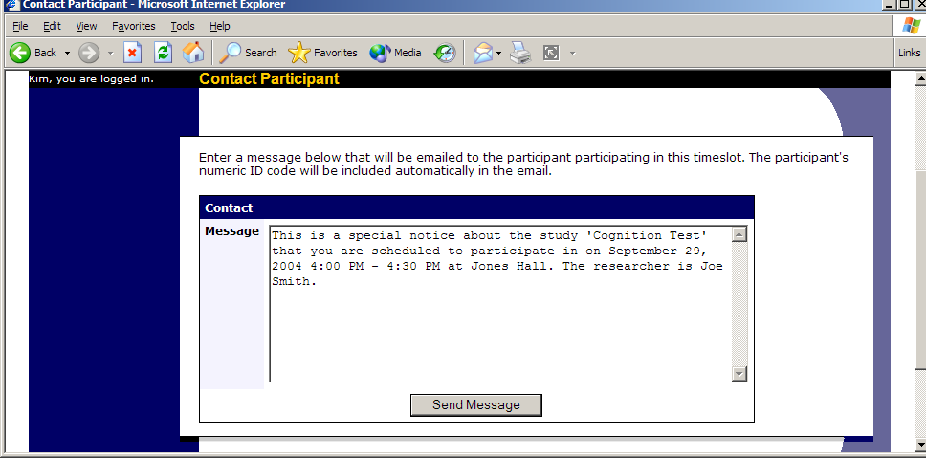
Figure 33 - Contacting Participants
In some cases, you may find it useful to contact all participants for the study, across all timeslots. This feature may be particularly useful if you are sending debriefing information when a study has concluded. To do so, go to My Studies, click Study Info. next to the desired study, and choose the Contact Participants option. You will then be able to select which group of participants to send to, and a message to send. Messages will be sent in groups of 300 (or less, depending on how your system is configured) to avoid overloading email servers. You cannot include attachments in the email, so if you have a document you would like to include, you should post it on a university webserver and provide a link to the document in the email you send.

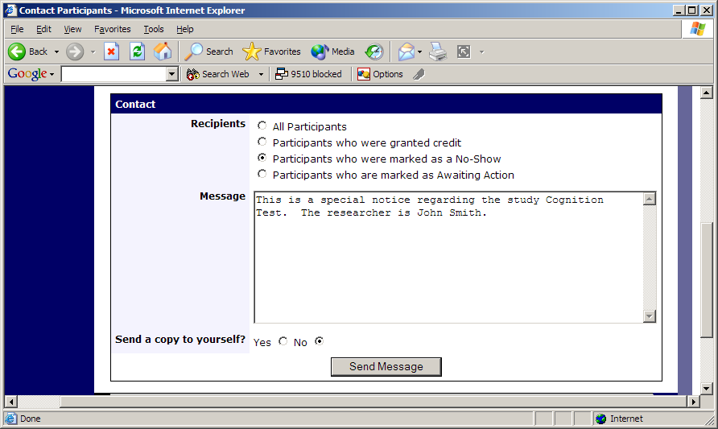
Figure 34 - Contact Participants
The From (sender) address on the email will be the administrator email address, which is done to prevent the email from being blocked by junk email filters. The “Reply To” address of the email will be that of the user who is actually sending the email, so when a user chooses to reply to the email, the reply will be sent to that (the reply to) address.

There is also the option to restrict the emails so they only go to participants who signed up for timeslots in a specified date range. The date range is based on the date of the timeslot, not when the participant signed up for, completed, or received credit for the study.

Finally, there is an option to specify a delay in sending the email, based on the number of hours from when the emailing option is used. This is useful if you want to target a certain time of day (e.g., during the evenings) when the email will be sent. The emails are generated at the time you use the emailing facility, but are stored on the server until the specified sending time. They cannot be removed from the queue once this emailing facility is used.

In most cases, summary information about the email you sent, and in particular to how many recipients it was sent to, will be logged and made available to the administrator. This is done to ensure there is no abuse of the email facility in the system, in compliance with generally accepted Internet practices for sending emails.

Viewing Uncredited Timeslots
When you login to the system, you will receive a warning if you have any timeslots that are more than 2 days old and haven’t been dealt with. You may view a list of all timeslots that have not been dealt with by choosing the View Uncredited Timeslots option from the My Studies page. The timeslots for online studies, including those in the future, are always considered in need of a response. See the Web-Based (Online) Studies section of this documentation for more information.

If you would like to do a simple credit grant (standard credit grant, no comments), you may do so directly from this page. Select the desired sign-ups/timeslots, and then choose Grant Credits. The action may take a short time to complete, so please be patient while the credit grants are processed.

If you need to do something more complex, like mark a no-show, add comments, or perform a special credit grant with a non-standard credit amount, you can easily click on the timeslot’s date and time, and go directly to that timeslot.

In cases where a study has timeslots linked to specific researchers, you will see the warning only for timeslots that are specifically linked to you, or to everyone in the study (i.e., not timeslots linked to someone else in the study). However, when you view uncredited timeslots, you will see all uncredited timeslots for your studies, even if someone else is linked to one of the timeslots for your study. This is done to make it easier to give your fellow researchers (for your studies) assistance in dealing with uncredited timeslots.

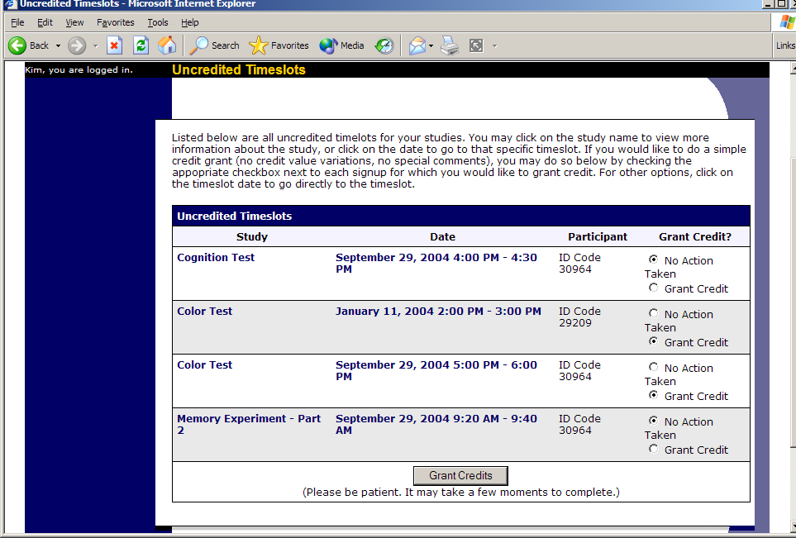
Figure 35 - Uncredited Timeslots

Analyzing Prescreen Responses
If online prescreening is enabled on your system, then you might also have the opportunity to analyze prescreen responses in aggregate or as raw data. Choose the Prescreen Results option from the top menu bar. You can then select which question you would like to analyze, and whether you would like to see summary data or raw data (in CSV format) for the selected question. The raw data will identify each participant only by a unique ID code, not by their name, for privacy reasons. If for some reason you need the participants’ real names, ask the Administrator to run the same analysis, as they can also pull the real names with their report. This gives you access to all prescreen data across all participants in the system.

If you would like to analyze the prescreen data for just those who participated in your study, select the Download Prescreen Responses after clicking on your study. See Viewing Prescreen Responses in this documentation for further information.

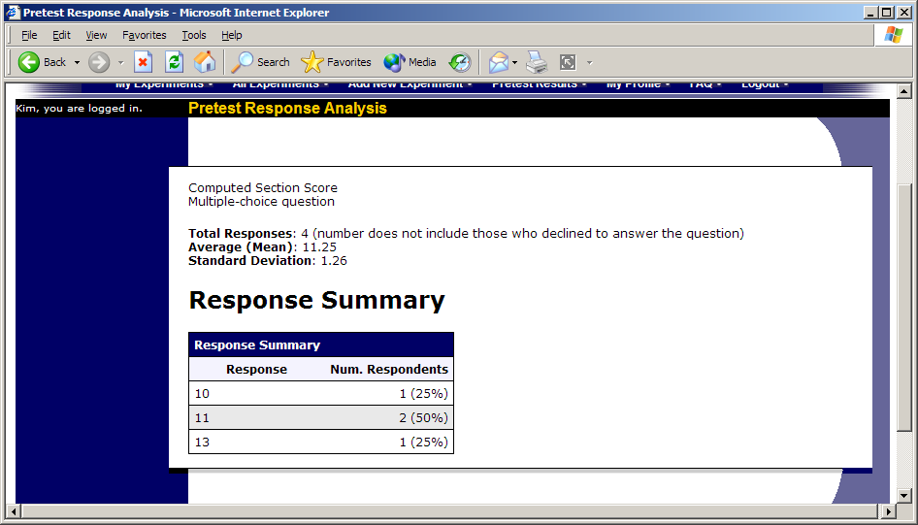
Figure 36 - Prescreen Response Analysis

Prescreen Qualification Analysis
If you would like to get an idea of how many participants meet a set of requirements (for help in setting prescreen restrictions on your study), use the Prescreen Qualification Analysis link from the Prescreen Responses page. Using this feature, you can select multiple questions (only questions that qualify for study participation restrictions are listed), and then the desired responses for those questions, and you will see how many participants meet that criteria.

If enabled, you may also contact participants and invite them to participate in any of your studies. See the Invite Qualified Participants to a Study section in this documentation for more information on how this works. The functionality is the same as the functionality described in that section, though a few options may be unavailable when not inviting directly from a study, because those options do not apply. Be sure to include information about how to sign up for the study in your communication to them, as a direct link to the study is not provided in the email.

Frequently Asked Questions (FAQ)

Why do I have to acknowledge the Human Subjects Policy?

Certain regulations and research guidelines either require or recommend it. You only need to do it once every 6 months, so it should not be too intrusive. You will not be asked to acknowledge the policy if this feature is disabled by your administrator.

What is the best way to setup a study where participants receive monetary compensation?

You may set it up as a pay study only (indication a compensation amount), or a credit study if it is for both pay and credits. See the Studies for Pay section of this documentation for more information.

I want to set up a study so that participants can choose to receive credit or payment. How do I set this up?

Set it up as a study for credit, and note in the study description that participants may opt to receive payment instead, and they should notify the researcher of this when they come to their appointment. If the participant at that time chooses to receive monetary compensation, the researcher should grant credit, but mark the credit as 0 credits (Variable Credit Granting must be enabled in System Settings by the administrator), and then note in the comments for the timeslot that payment was received.

The monetary compensation a participant receives for a study depends on decisions they make during the study. How do I indicate this?

You must enter one value when setting up the study, so enter the minimum payment value (or 0) or whatever you feel is appropriate, and then note in the study description the entire range of compensation that is possible.

I want a participant to participate in an upcoming session, but the system says it is too late for them to sign up. What do I do?

If enabled, you can perform a manual sign-up. See the Manual Sign-Up section of this documentation. If not enabled, your administrator can still perform a manual sign-up.

Where are email notifications to me sent?

Email notifications (e.g. sign-up notices) are sent to either an address derived from your user ID or your alternate email address. See the Email Address Options section of this documentation for more information.

How do I deal with dyads?

A dyad is a study which requires a pair of people to participate, but often the second participant is not a “real” participant, but rather a colleague of the researcher who is “colluding” with the researcher as part of the study itself.

You do not need to deal with dyads in the system itself. Participants cannot see how many people have signed up for a timeslot, nor how many spaces are available for a timeslot. So, your “fake” participant can just act like a real participant and the real participant will be unaware of this.

I have finished running my study. What should I do?

So it does not clutter the list of studies for participants, you should make the study Inactive. See the Updating a Study section of this documentation for more information.

Who has access to my studies?

All users can see the information about your studies and the available timeslots. Administrators, the principal investigator (if applicable) and the researchers for the study are the only people who can see who has signed up, and modify the study.

Regulatory Compliance Guidelines

Introduction
This software complies with all major regulations governing human subject research and privacy of data stored online. The system complies with both HIPAA and Common Rule for customers in the United States. For customers in Canada, it complies with the Personal Information Protection and Electronic Documents Act as well as the Tri-Council Statement. For customers in the European Union or in countries that follow OECD rules, it complies with OECD privacy rules and the European Union Directive of Data Protection. Your organization may or may not need to comply with the relevant regulations. Your subject pool administrator can advise you on this situation.

Even if you are not required to comply, compliance is still a good idea, as protecting sensitive data is always a good thing. Compliance in the context of this system is as simple as reading the remaining paragraphs of this section (that apply to your organization) and following the guidelines contained therein. The remaining compliance issues involving software, privacy and electronic data storage are all handled automatically by the software. You should still consult with your IRB or organization to learn about additional compliance rules you must follow outside of use of this software (the handling of the data you collect during your study would be one example).

Some regulations (particularly the US HIPAA regulations) are focused primarily on health data. You may think the system does not store confidential health data (in HIPAA terms, it is called PHI -- Protected Health Information), but depending on how your organization uses the software, there may very well be confidential data in the system. Consider the case of a study that requires that a participant come from a family that has a history of mental illness. Merely knowing who signed up for that study can be considered confidential because that type of information should not be revealed to the public. It may turn out that your studies are not of such a nature, but even more benign situations, like a study that requires that participants be regular contact lens wearers, can be construed as confidential information. Organizations typically err on the side of caution given the criminal and civil penalties for violation of these types of regulations.

Data Handling and Security Guidelines
In your role, you have access to your studies and you can see who has signed up for those studies. You may also have access to prescreen responses. Because of these privileges, you should follow these simple guidelines:

- Secure Your Account. Use a password that is difficult to guess. The most secure passwords contain a combination of letters and numbers, do not spell a real word, and are at least 8 characters long. Your university IT department can provide you with assistance on choosing a secure password.
- Secure Your Work Area. If you are logged into the system and you leave your computer, you should logout of the system or use a password lock on your computer. Ask your network administrator for help with setting up a password lock.
- Handle Paper Documents Carefully. Any printouts from the system should be kept reasonably secure. Store them in desk drawer out of the public view. Documents you decide to discard should be shredded if possible.

Human Subjects/Privacy Policy Acknowledgment
Upon your first login to the system, and every 6 months thereafter, you may be required to acknowledge your organization’s policy on these matters, and this acknowledgement will be logged. Ask your subject pool administrator if you have any questions.

INSTRUCTOR DOCUMENTATION

Introduction
The Experiment Management System is used for the scheduling and management of a human subject pool. As an instructor, your interaction with the system will be minimal, but also painless. Your primary use of the system will be to check on the credit status of students (participants) in your courses, though in some cases you may also have the ability to grant credits to your students, as well as view which studies are available to students.

Getting Started
The system works best if you use a web browser that is less than 2 years old. It works well with all recent versions of Internet Explorer, Firefox, and Safari. It will work with other web browsers, and with older versions popular browsers, however the layout may not be as clean. No functionality will be lost by using an older web browser. Ask your IT department if you need help with installing or using a web browser. This documentation assumes you have a basic knowledge of how to use the web. On this system, it is not necessary to use the Back button. You can always use the toolbar on the top to navigate anywhere on the site.

Logging In
To login, go to the front page of the site (you will be given the URL by a member of your organization) and type in your username and password. If you have forgotten your password and the system is configured to allow password retrieval, you will see a link where you may choose to have your password emailed to you. Once you login, you will be presented with a Main Menu with a few options.

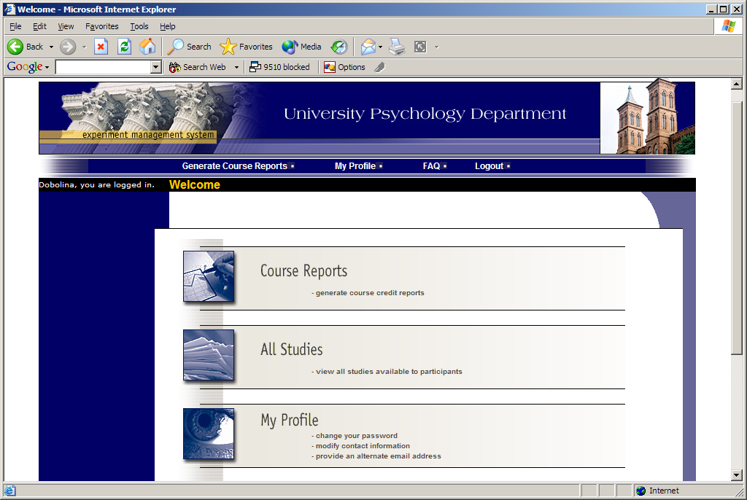
Figure 37 - Main Menu

Course Reports
On the Main Menu that you see after logging in, you will see an option to generate course reports. Once you click on that, you will see a list of all the courses you are listed as an instructor for, and you have the option to generate reports for each of those courses.

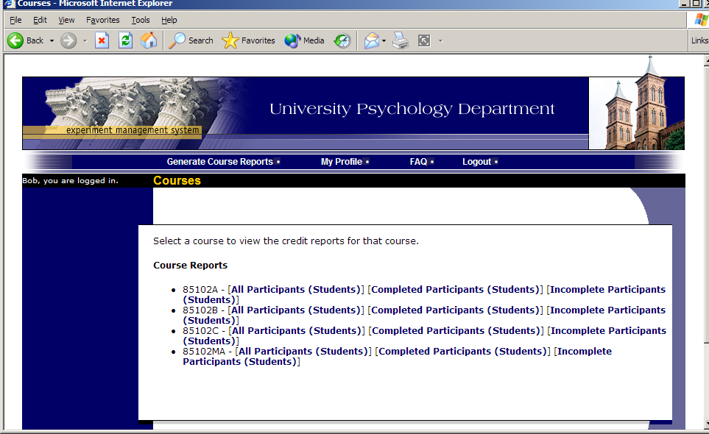
Figure 38 - Course Listing
You have 3 choices for the type of report you would like to generate. All Participants will list all participants in the course. Completed Participants will list only participants who have met or exceeded their credit requirements. Incomplete Participants will list only participants who have not met their credit requirements. Click the link for the desired report.

The report will be listed in alphabetical order by a participant’s last name, and participants that have not completed their requirements will be highlighted in bold. For privacy and research ethics reasons, you will never see exactly which studies the students participated in – only a summary of their credit earnings. If for some reason this information is needed, the administrator can produce such a report for you using the Course Credit History report available to them.

If your system is configured as such, you will see a credit status for the participant overall, as well as for the listed course. If this is the case, you should look at a participant’s credit for the course to determine if they have completed their requirements. If you do not see such a column (“Credits Earned for Course”), then you only need to be concerned with the overall credit completion status for the participant. If the report is too wide to be printed easily, you can use the Printer-Friendly format. A link to that will appear at the bottom of the report.

If you would prefer to deal with the information in CSV (comma-separated) format (for easy import into a spreadsheet program like Excel), use the CSV link at the bottom of the report to generate such a data file. If you have problem working with the CSV format file, please contact your IT department for assistance – CSV is a standard data format and they be quite familiar with it.

To generate a new report, choose the Main Menu link from the left toolbar and proceed from there.

Granting Credits
In some cases, you might see a Grant Credit choice next to each name when you generate a course report. If you click on this link, you can grant a non-study credit grant to that student. This is useful if you are in charge of granting a student credit for participation in a research alternative (e.g., writing a paper), in lieu of actual research participation. To grant the credit, simply enter the credit value and a comment about the credit grant, and the credit will be granted immediately. If you grant a credit by mistake and would like to delete it, please contact the administrator and they can do this for you.

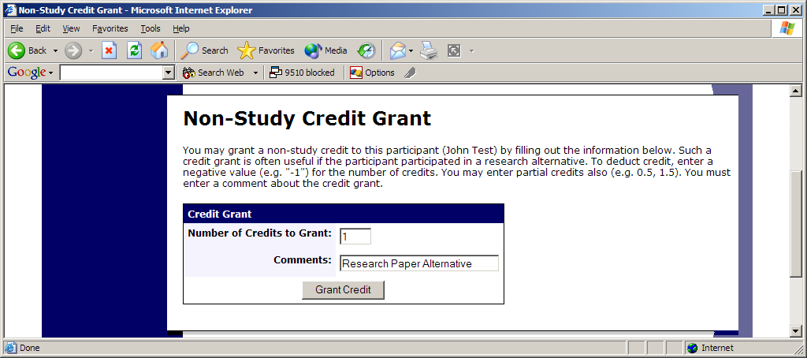
Figure 39 - Non-Study Credit Grant

Viewing Studies
In some cases, you may have the ability to view what studies are available in the system (to students). This is useful if you want to discuss information or concepts from those studies in class, as a part of the educational experience. If such an option is available, you will see an All Studies link after you login. If you click this, you will see a list of studies, and you may then click on any study to view more about it. For privacy reasons, you may not see who has signed up for any of the studies.

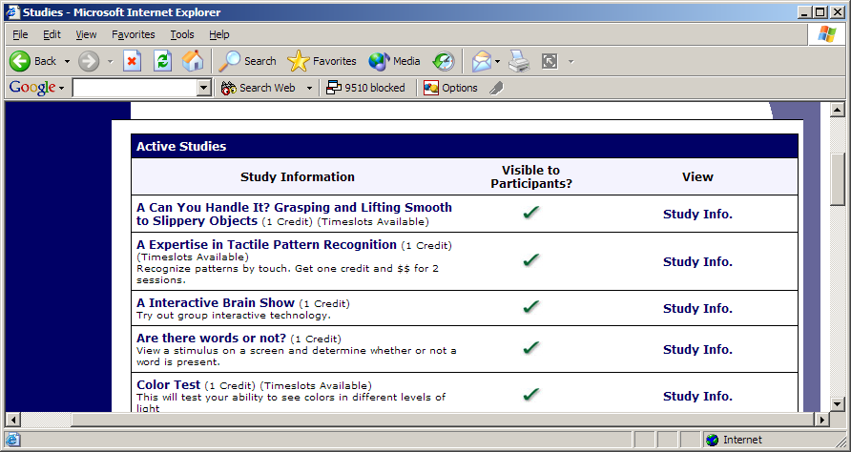
Figure 40 - Viewing Studies

Changing Your Password
To change your password or other information, choose the My Profile choice from the toolbar. Fields marked with (+) are optional and do not need to be filled out.

If you change your password, please be sure to select a password you do not use on any other systems or websites. This is good computing practice, and especially important as in some cases, your password may be sent over email.

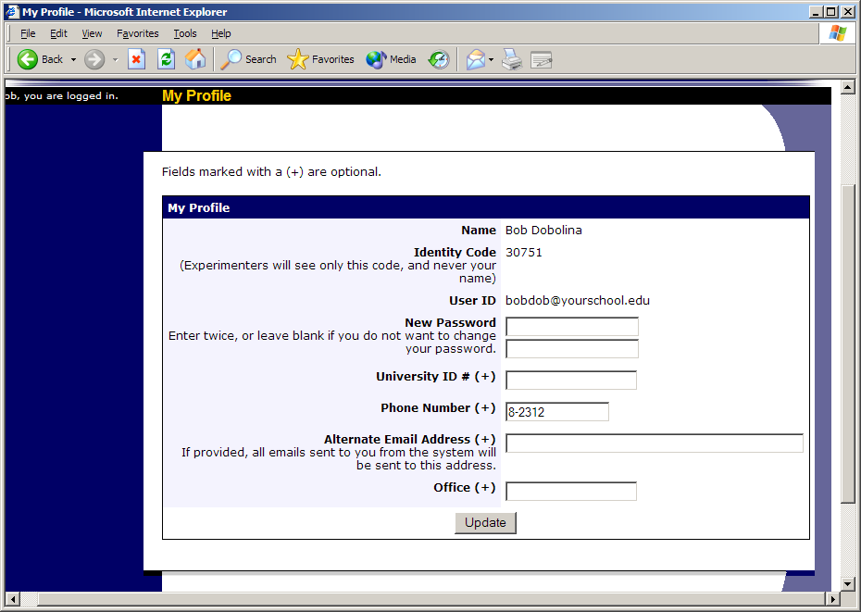
Figure 41 - Updating Your Profile
In situations where the system is configured so you may enter an email address on this page, you will be asked to enter it twice when changing the address, to ensure it is typed correctly.

Logging Out
When you are done using the system, choose Logout from the top toolbar to log out. You are now logged out. It is always a good security measure to close all your browser windows as well, especially if you are using a computer that is shared by others.

Frequently Asked Questions (FAQ)
I have a few people who act in multiple roles (e.g. researcher and administrator). How should I create their account in the system?

You should create two accounts for them, as each user type has a different set of privileges. See the Duplicate User IDs section of this documentation for more information.

I would like to deduct or add credit from a participant. How do I do this?

The easiest way is through the non-study credit grant feature. You have the option to grant a negative credit if you would like to deduct credit, or you may grant a positive credit. See the Granting Non-Study Credit section of this documentation for more information.

A participant failed to show up for a study and did not properly cancel, but there were extenuating circumstances and we would not like to penalize the participant. How should this be handled?

Researchers should take some action on every study timeslot that has occurred. If you system is configured to assess penalty credits, then the researcher will have the option to indicate the participant did not show, and whether the no-show was worthy of a penalty (in this case, it is not).

If your system is not configured to assess penalty credits, then the researcher should indicate the participant was a no-show.

The reason to always properly indicate a no-show for a participant is that the system makes certain pre-requisite enforcement decisions (and other decisions) that depend on whether the participant participated in the study or was a no-show.

You may also cancel the participant’s sign-up, if appropriate.

I want to change the number of credits a participant must complete, for a particular participant (as opposed to changing the default setting). How do I do this?

Edit the participant’s record (see Editing Users) and you can adjust their credit requirements. Partial credits are allow up to two decimal points of accuracy (e.g. 0.5, 1.25, etc.).

Participants go to create their own accounts, but no courses show up on the account request form and they seen an error instead. What is wrong?

You need to create at least one course that is Selectable. See Course Maintenance in this documentation for more information.

I would like to export a copy of the data, for archival purposes. How do I do this?

You can use the Data Export feature for this, at any time. See Exporting Data in this documentation for more information.

One of our researchers works for a different organization, and thus they do not have an email account in our organization’s email system. How do I setup their account?

When you create their account, choose a username that is not already used and is not a currently valid email account. Then, specify their real email address (at the other organization) in the Alternate Email field. By specifying the alternate email address, the alternate email address will be the address that is visible to other users of the system.

Can there be different sign-up or cancellations deadlines for each study?

Yes, if study-level deadlines are enabled on your site (see System Settings).

System Settings
System settings are accessed from the System Settings choice on the Set Up toolbar. You must be logged in as an Administrator to access this option.

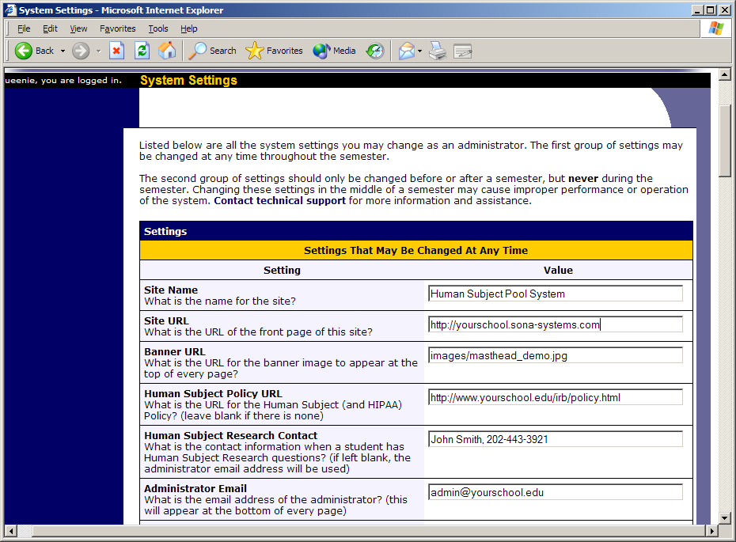
Figure 70 - System Settings
System settings are organized into two sections. The first section contains settings that may be changed while there is data in the system. The second section contains settings that should only be changed if there is no data in the system. Do not change this second group of settings at any other time, as it can lead to corruption of data, as well as unexplainable results. If you absolutely must change a system setting from the second section while there is data in the system, contact Sona Systems technical support first and they will provide guidance on how to safely change these settings. In many cases you will be given the OK to make the change on your own, but it depends on how you’d like to change the setting (from what to what), so please include that information as well.

System settings are accessed from the System Settings choice on the Set Up toolbar. The form provides an easy method to change any settings. Changes you make will be reflected immediately after you save the changes. All settings below are required unless otherwise noted.

Settings That You May Change at Any Time

Setting Name | Description
Site Name | The name of the system. This is used throughout the system as the header/banner at the top of the screen. It is also the From: name on emails generated by the system. Most organizations choose a name that includes “System” at the end (e.g. “Research Participation System”) but such a naming convention is not mandatory.
Site URL | The URL (web address) for the site. This is used in emails sent to users with their login information, and in some other places throughout the system. The URL should start with the conventional http:// to indicate it is a URL.  If you would like to change the address of your site, please contact technical support as this will require some adjustments on the server.
Banner URL | The URL (web address) for the banner/masthead image that appears at the top of every page on the site. If the image is located on a server different from the software, it should start with http://. If it is located on the same server as the system, it may be a “relative” URL and will likely start with “/”. Banner images may be of any size, but the recommended size is 500 pixels wide and 85 pixels tall, in JPG or GIF format.
Human Subject Policy URL | This field is optional. If your organization has a URL for its policy on human subject research and/or or its privacy policy, then you can place the URL here. The URL should start with “http://”. If provided, this link will be provided to all logged-in users in the Human Subjects/Privacy Policy link at the bottom of every page.
Human Subject Research Contact | This field is optional. If not provided, the Administrator Email address will be used. This is a free-form field, so you can type in as much contact information as necessary. One example value would be “John Smith, jsmith@yourshool.edu, 415-555-1212, Smith Hall 332”. This information is listed in the Human Subjects/Privacy Policy link at the bottom of every page.
Administrator From Email | A special email address which forwards to the administrator. This is used as the From (sender) address on all system-generated emails, including credit notifications, password reminders, and study reminders. The email address usually ends in @sona-systems.net, and this is done to get around junk mail filters at many universities, which do not like if it a non-university server (like ours) generates emails with a university email address. When the system sends email where the From address is an @sona-systems.net address, then these emails are specially signed by both DomainKeys and DKIM, and are both Sender ID and SPF compliant. These techniques are invisible to the user, but make it more likely that the email will not be misclassified as junk mail.  If there is an @sona-systems.net email address specified here, then email sent there will forward automatically to the email address specified in the Administrator Reply-To Email setting (see below).
Administrator Reply-To Email | The email address where users should write if they have questions about the system (i.e., the administrator’s email address). This is likely a university email address, and cannot be an @sona-systems.net address. Automated emails from the system will have this email address specified as the “reply-to” address, which means when a user responds to such an email, their response will go to the Administrator Reply-To address. This address is also displayed at the bottom of every page on the site, so users can easily contact the administrator if they have any questions.  In some user-initiated emails, like if a researcher is sending a prescreen participation invitation, the reply-to address will be set to that of the user initiating the email.
Participant Human Subject Policy Acknowledgment | Yes or No value to indicate if participants must acknowledge the Human Subjects/Privacy Policy before they may use the system. If set to Yes, they must acknowledge it once every 6 months, and their acknowledgment status will be listed in their record when the Administrator views it. If you handle this type of acceptance before-hand (on paper, for instance), then it is usually not necessary to enable this feature.
Researcher Human Subject Policy Acknowledgment | Yes or No value to indicate if researchers and principal investigators (when applicable) must acknowledge the Human Subjects/Privacy Policy before they may use the system. If set to Yes, they must acknowledge it once every 6 months, and their acknowledgment status will be listed in their record when the Administrator views it. If you handle this type of acceptance before-hand (on paper, for instance), then it is usually not necessary to enable this feature.
Human Subject Policy Type | Choose the research and privacy regulations that your organization must comply with. The choices are United States (HIPAA and Common Rule), United States (Common Rule only), Canada (PIPEDA and Tri-Council Statement, European Union (OECD and EU Directive), or Australian (OECD). The system will automatically adjust the policies based on your selection.
IRB Name | The name of the group that approves studies. Usually called an IRB, REB, or HSB. The name may be up to 20 characters, and this name will be used when identifying the IRB to researchers and participants. Use of an acronym is recommended to save screen space.
Default Study Length | The default length of time for a study, in minutes. Researchers may change this value on a study-by-study basis.
Sign-Up Time Threshold | The latest time before a study is to occur that a participant may sign up for a study. You may choose a rolling time window (e.g. 24 hours before the study is scheduled to occur), a fixed time (e.g. 5pm the day before), or allow this to be specified on a per-study basis. The fixed time setting always indicates the day before the study is to occur.
Cancellation Time Threshold | The latest time before a study is to occur that a participant may cancel their sign-up for a study. You may choose a rolling time window (e.g. 24 hours before the study is scheduled to occur), a fixed time (e.g. 5pm the day before), or allow this to be specified on a per-study basis. The fixed time setting always indicates the day before the study is to occur.
Time Threshold Includes Weekends | Yes or No value to indicate if the system should factor in weekends when enforcing the sign-up and cancellation time limits. If set to Yes, then a deadline that would ordinarily occur on a weekend is pushed back to the Friday before the weekend. The system will push back the deadline in full days, so a rolling time window threshold that would occur at 2:30pm on Sunday would be moved to 2:30pm on Friday. If set to No, the deadline may occur on a weekend.
Random Study Order | Yes or No value to indicate if the system should list studies (to participants) in random or alphabetical (by study name) order. All non-participants will always see studies listed in alphabetical order.  If random order is chosen, the list of studies is randomly listed every time a participant views the list of available studies.
Credit Display | Yes or No value to indicate if the credit value for studies should be listed on the study listing page, for participants. The credit value will always be visible once a participant clicks on a study to learn more about it. The reason to disable the credit display from the main study listing page is if there is a concern that participants are more or less likely to view studies that have a higher credit value. If set to Yes, the credit value will be displayed on the study listing page.
Available Study Display | Yes or No value to indicate if all (active, approved) studies should be displayed to participants when they go to view the list of studies. If set to No, then only those studies with available timeslots will be listed. It may be useful to set this to Yes if there are frequent changes in timeslot availability and you want to make a participant aware of studies even if there are no timeslots available at the moment.
Online Study Display | Yes or No value to indicate if on the list of studies displayed to participants, participants can see immediately if the study is an online study. If this is set to No, there will be no indication on the page listing all the studies to participants that the study is an online study. This may help to reduce selection bias.  Regardless of this setting, once the participant clicks on a specific study, they will see at that point if it is an online study, as they need to know this for logistical reasons.
Participant Progress Display | The starting date to display activity when a participant views their progress. Activity prior to this date will not be displayed unless the participant clicks an option to do so. This is useful to avoid clutter and confusion on this page, if older studies are kept in the system for archival purposes.
Pre-Requisite/Disqualifier Display | Yes or No value to indicate if participants can see the study pre-requisites and disqualifiers for a study. If set to Yes, then when participants view a study with study pre-requisites or disqualifiers, they will see the list of those studies and also whether or not they satisfy each requirement. If set to No, then the system will indicate that they are not eligible due to study pre-requisite or disqualifier restrictions, but not state which studies are the reason they do not qualify.  The benefit to setting this to No is if there is a risk to the research quality if participants know what studies are related. The benefit to setting this to Yes is that there are likely to be fewer support emails from participants asking why they cannot sign up for a certain study.  The Pre-Requisite feature must be set to Yes for this setting to work.
Variable Credit Grant | Yes or No value to indicate if researchers can grant partial credit to a participant for study participation. If set to Yes, researchers can grant from 0 credits to 2 times the study’s credit value. This is useful when a study runs longer than expected or a participant leaves the study early. The range of credit values can be granted depends on the Credit Increment setting.
Instructor Study Viewing | Yes or No value to indicate if instructors can view the studies available in the system. This is useful if instructors would like to know what studies are available so they can integrate such information into their instruction. Even if this feature is enabled, instructors still cannot see any timeslots nor who has signed up for the study, for privacy reasons. If set to No, instructors may not view any studies.
Instructor Credit Grant | Yes or No value to indicate if instructors can grant non-study credit grants to participants (students) in their courses. This feature is useful if credit for a research participation alternative is handled directly by the instructor. If set to No, this feature will not be available to instructors, but still remains available to the administrator.
Sign-Up/Cancellation Confirmation Email | A choice indicating if the system should email a participant with a confirmation of their study sign-up, immediately after they sign up. It can also be sent when the participant cancels their sign-up. Note that when someone other than the participant cancels the sign-up (e.g. the administrator or researcher), a confirmation email is always sent since the participant may not otherwise be aware of it.
Automatic Reminder Email | Yes or No value indicating if the system should send a reminder email to participants the day before they are scheduled to participate in a study. If set to yes, an email will be sent automatically the day before their appointment.
Automatic Reminder Email Delay | The number of hours the system should hold the study reminder emails in the queue before sending them. This is useful if participants are more likely to pay attention to an email if it is received at a certain time of day. The emails are usually sent at 5pm New York time. If a delay is specified, the emails will still be generated at that time, but will be held in the email server queue until the specified delay is reached.
Credit Notification Email | Yes or No value indicating if the system should send an email to the participant when they are granted (or revoked) credit for a study. If set to Yes, an email will be sent. This only applies to studies for credit, not for studies set up as being for payment.
Administrator No-Show Notification Email | A numeric value indicating after how many no-shows a participant receives should the administrator be notified by email. Some schools like to disable a participant’s account after they accumulate a number of no-shows. The administrator should review the participant’s account before deactivating it, in case the researcher later changes the no-show to a credit grant. Set this value to 0 to disable the feature. If set to any value above 0, the administrator will be emailed as soon as a participant accumulates or exceeds the specified no-show value. The no-show count is based on the combination of penalty-earning and no-penalty no-shows (when applicable). See Participants with Excessive No-Shows for more information.
Administrator Account Notification Email | Yes or No value indicating if the system should email the administrator every time a new account is requested (by a participant). If set to Yes, an email will be sent. Many schools choose to disable this feature when the term is starting, as the administrator is frequently logging onto the site and checking for new accounts. As the term progresses, they enable this feature so they are aware of any account requests, as they trickle in mid-term. This feature only applies if Participant Account Self-Creation is enabled.
Administrator Pending Timeslots Email | A choice indicating if the system should send a notification email if there are pending timeslots in the system more than 2 days old that have not been dealt with. You may choose to have this sent for al studies, or only non-online studies. The reason not to enable this notification for online studies is that online study notifications are considered eligible (for a notification to be sent) as soon as the sign-up has occurred, since it is difficult to determine when the sign-up occurred while figured the two-day threshold. This email is sent once per day, and only if there are timeslots that meet the criteria.
Automatic Account Approval | Yes or No value indicating if participant account requests should be approved immediately, without administrator intervention. This feature only applies if Participant Account Self-Creation is enabled. To receive notification of these automatic approvals, enable the Administrator Account Notification Email setting.
Automatic Credit Granting | Numeric value indicating whether the system should automatically grant credit to a participant if the timeslot is more than X hours old, and the researcher has taken no action. The value for X indicates the number of hours old a timeslot must be before it qualifies for an automatic credit grant. For example, if this was set to 5, then only timeslots more than 5 hours old qualify for the automatic credit grant. The automatic credit grant occurs once a day, usually overnight. The automatic credit grant also takes place for studies that are for-pay, and it also grants credit for online studies, once the participation deadline has passed. Researchers can always override an automatic credit grant later, if necessary. Set this value to 0 to disable the feature.
Automatic Credit Grant Administrator Email | Yes or No value indicating if the administrator should receive an email with information about all studies where automatic credit grants occurred. This is useful to keep track of situations where researchers are not granting credits in a timely manner. Only applies if Automatic Credit Granting is enabled.
Lost Password Feature | Yes or No value indicating if the Lost Password feature should be enabled. If enabled (set to Yes), users may have their password emailed to them through a link on the front page of the site, if they forget their password. Typically, the only reason to disable this feature is if there is a concern about sending passwords over email.
Change Password Feature | Yes or No value indicating whether participants are allowed to change their password after their account is initially created. Generally this should be set to Yes, but some organizations set it to No if they have created participant accounts using a specialized password scheme.
Administrator Password Retrieval | Yes or No value indicating whether the administrator can view the existing passwords of users. If set to No, the administrator can only set a new password for a user, but not view their current password.
Study Approval | An option indicating if the administrator must approve a study before it is made visible to participants. This can be turned off entirely, enabled only when a study is added, enabled when a study is added or updated, or enabled when a study is added with an email to the administrator upon an update. Approval is controlled by the “Approved” field in a study, not the Active/Inactive setting for a study (which researchers control).  Note that if approval is only required when adding a study, it is possible for a researcher to add a study, then go in and update it to make it visible to participants. If this is a concern, you should either enable email notification on the update, or enable approval for updates also.  A study is considered “updated” if the descriptive text fields (name, descriptions) is updated. More specifically, a study will require re-approval by the administrator if this setting is set so that a study requires re-approval when the study is updated, and at least one of the following fields about a study are changed: study name, brief abstract, detailed description, eligibility requirements (the text field, not specific restrictions like prescreen restrictions, study pre-requisites/disqualifiers, or course restrictions), duration, preparation, credit value (for credit studies only).  If the setting is set so that on an update, the administrator merely receives a notification but no re-approval is needed when a study is updated, then in addition to the fields mentioned above, an email will also be sent when a study that was not previously visible to participants (approved) is made visible. The email notification to the administrator (if enabled), will detail the changes made to the relevant fields. This email notification will not be sent to the Study Approval Contact, even if one is specified.
Study Approval Contact | If studies require approval by an administrator before being approved so it is visible to participants (see Study Approval setting), then you may specify the email address of where these approval requests should be sent. In some cases, the main administrator for the site is different from the person responsible for approving studies, which is why this may be useful. If this is the same person, leave this blank and the email will go to the administrator.  If an email address is specified here, be sure the email address is that of someone who has administrator access to the system so they can actually approve the studies. Only an email address should be entered, and not any additional text like a name.
Researcher Manual Sign-Up/Cancellation | An option indicating if researchers can sign up and/or cancel a participant for their study. The sign-up option is useful if researchers have a need to override a study’s restrictions (pre-requisites or sign-up deadlines, for example), which participants cannot do. The option can be turned off, set to Sign-Ups only, Sign-Ups and Cancellation, or Sign-Ups and Cancellation with an email notification to the administrator when there is a cancellation. Even if the feature is disabled, the administrator can still perform the function if necessary. During a cancellation, the participant always receives an email notification, along with a confirmation code, to help in settling any disputes that may arise.  The manual sign-up feature for a study is not available to researchers if a study has not been approved and it requires approval by the administrator (Study Approval setting). This is to ensure that no sign-ups can occur prior to a study receiving approval.
Researcher Reminder Email | Yes or No value indicating the default value when a new researcher account is created. If set to Yes, researchers will receive an email the day before they have studies scheduled, as a reminder. They will also be sent an email if they have any timeslots more than 2 days old that haven’t been dealt with. Regardless of this setting, researchers may override the default setting individually, if they so desire, by going to their profile.
Participant Display Order | The order that participants are displayed when researchers view a list of who has signed up for their study. Names can be ordered by first (given) name or last name (surname). If Anonymous ID codes are enabled, then researchers will not see names, in which case this setting would only apply to the administrator, since the administrator can always see participant names. In this situation, researchers will see the list of participants sorted by anonymous ID code.
Phone Number Display | Yes or No value indicating if researchers and principal investigators can view the phone numbers of participants who have signed up for their study. If set to Yes, the phone number is displayed, if it is available.
Participant Identification | Determines how participants are identified to researchers. The options are by Full Name, by First Name only, or by a unique, system-assigned ID code. The last option ensures the highest level of privacy. The First Name only option is useful so researchers can identify and address participants, while still affording participants some level of privacy. See Participant Unique ID Codes for more information.
Prescreen Viewing | Yes or No value indicating if researchers can view the results of an individual participant’s prescreen, if that participant has signed up for the researcher’s study. This setting only applies if online prescreening is enabled (see Online Prescreens). If set to No, researchers cannot view any individual participant prescreen results (though they can view aggregate results across all participants).
Prescreen Aggregate Viewing | Yes or No value indicating whether researchers can view and analyze prescreen responses for a chosen question across all participants. If enabled, researchers can also download the response data for the chosen question. Participant names are not included in this data, but responses may contain identifying information. This setting only applies if online prescreening is enabled.
Prescreen Contact | Yes or No value indicating if researchers can contact a group of participants who meet a certain criteria, to invite them to participate any of their studies. The email contact is made through the system in such a manner that the participant’s identity is not revealed to the researcher. Some schools are required to disable such a feature, as their IRB considers it coercion. This setting only applies if online prescreening is enabled.
Prescreen Contact Limit | A numeric value between 1 and 999 indicating the maximum number of participants a researcher may contact at one time, based on running a prescreen analysis and contacting those who meet their specified criteria. For more information, see Invite Qualified Participants in the Researcher section of the documentation.
Prescreen Contact Admin CC. | Yes or No value indicating if the administrator should receive a copy (by email) of any communications sent to participants by researchers, using the Prescreen Contact feature. If set to Yes, an email will be sent to the administrator with the contact of the communication, which is useful if the administrator would like to monitor the content of such communications (generally to be sure there is no coercion). The email will also contain some basic summary information about which emailing options were chosen and how many participants received the email. Only applies if the Online Prescreening and Prescreen Contact settings are enabled.
Prescreen/Survey Concurrent Participant Limit | A number between 1 and 10 to indicate the maximum number of participants who can be taking the prescreen or any online survey studies at the same time. The limit is arrived at by adding up all participants taking the prescreen or any online survey studies (combined). The reason to set a low limit is for improved system performance, as too many participants may slow the system down. Those who attempt to participate after the limit is reached will be told they are temporarily prevented from participating, along with an estimate in minutes of how soon there is likely to be more space available. If the prescreen or most online surveys take a while (more than 5 minutes) complete, it is a good idea to set this limit to a low number. A list of who is currently participating is in the System Summary Report.
Course Credit Reassignment | Yes or No value indicating if participants can reassign a credit from one course to another. This only applies if Course Credit Assignment is enabled, and a participant belongs to multiple courses.
Course Reassignment | Controls whether participants can change which courses they are in, after their account is initially created. The three options are:  - No – They cannot change which courses they are in (however, the administrator may do this for them if necessary).  - Yes, Add and Remove Courses – Participants can remove themselves from their current courses, as well as add themselves to other courses.  - Yes, Add New Courses Only – Participants can add themselves to other courses, but may not remove themselves from any courses they are currently in.  If this setting is enabled, then a participant may change which courses they are in if any one of the following is true:  - No-show penalties are turned off (see No-Show Penalty Credits setting)  - The system is configured to assess no-show penalties, but those penalties are deducted from earned credits (see Penalty Type setting)  - The system is configured to assess no-show credits, and penalties are added to credit requirements, but the participant has not received any no-shows yet  It is important to note that if a participant removes themselves from a course, and there are credits assigned to that course, then those credits will become unassigned (they will be advised about this with a warning message). Unassigned credits can be reassigned by the participant to any course they are currently in.
Change Log Level | This feature is not yet implemented, and can be set to any numeric value (0 is recommended).
SMTP Relay Server Address | The hostname or IP address of your SMTP relay server. If you run the software on your own servers, your network administrator will have this information. It must be an “open” relay server. If Sona Systems runs your software, this is already taken care of and should not be changed.
Current Time | Set this value to reflect the current time at your organization. This is just a time zone adjustment. If Sona Systems runs your software, the time will adjust automatically during the Daylight Savings Time switch for the USA. If you are in an area that follows different Daylight Savings Time rules, please check this value on the second Sunday in March and the first Sunday in November, and adjust it accordingly.
Date Format | The format in which the system will display dates and times. Choose from either North American (July 14, 2001, 1:30 PM) or European (14 July 2001, 13:30) formats.
Compensation Type | Text to indicate the unit used when studies are offered for monetary compensation. Usually this is the name of your local currency (Dollars, Pounds, etc.). Even if you do not currently offer studies for compensation, you should specify some value here.
Credit Type | Text to indicate the unit used when studies are offered for non-monetary compensation. Examples include “Credits” and “Points.” Even if you do not currently offer studies for credit, you should specify some value here.
License Key | Your 17-digit license key will be provided by Sona Systems. The expiration date will be listed. If your license key has expired or is invalid, then only Administrators may login to use the system, and all other users will be prevented from logging in.

Settings That May Only Be Changed when the System is Empty
The table below lists settings that should only be changed when there is no data in the system. It is very important that you do not change these settings while there is data in the system, or you may lose data and the system may not perform as expected. If you absolutely must change a setting, contact Sona Systems technical support first and they will help you make the necessary changes without a loss of data integrity.

Setting Name | Description
@ Suffix | The @ suffix (domain) for all usernames. The system can use user IDs that resemble email addresses. Most schools have an email system with unique email addresses, such as “username@yourschool.edu” (in this example, the @ suffix value is “yourschool.edu”). The intention here is that user IDs must be unique in the system, so using an organization’s unique email user ID convention is the best way of enforcing this uniqueness. User accounts on this system are not connected in any way to the university email system. See the User IDs section for more information on how user IDs are handled. The value you supply should not include the leading “@”.  If you do not have a common @ suffix (domain) to map it to, you can leave this blank. If you leave it blank, the system will allow users to choose any user ID, but will also require them to provide an email address so they can be contacted by the system when necessary.
Prescreen Requirement | Are prescreens required of participants before they may login? There are 3 options for this setting.  If you do not deal with prescreens, or you would not like the system to deal with prescreens, then set the value to No Prescreen.  If you would like the system to administer a prescreen online, you should set this value to one of the two Online Prescreen options. If this setting is enabled but there is no active prescreen in the system, participants will be allowed to login. On subsequent logins, if a prescreen is now active and available, they will be sent to the online prescreen. See Online Prescreens for more information.
Credit/Pay Support | This setting determines if support for pay and/or credit studies should be disabled in the system.  Note that this setting is mostly cosmetic, and does not change the majority of system functionality. It only changes some text and pages for participants and researchers.  If pay support is turned off, then researchers cannot add studies where there is monetary compensation.  If credit support is turned off, then researchers cannot add studies for credit. In addition, on pages where participants go to view their credit earning status, no reference to credit is made. Finally, on emails to participants confirmation participation or sign-up for a study, no reference is made in the email text to credits.
P.I. Support | Yes or No value indicating whether the P.I. (Principal Investigator) feature should be enabled. If enabled (set to Yes), you may create P.I. users, and a P.I. is required for every study. See Principal Investigator Accounts for more information.
Multiple Researcher Support | Yes or No value indicating if a study can have multiple researchers linked to it. If set to Yes, a study can have multiple researchers. Each researcher (for the study) has full and equal control over the study. If enabled, then Timeslot Usage Restrictions can be enabled only on a per-study (not per-researcher) basis.
Strict IRB Mode | Yes or No value indicating if the system should operate in strict IRB mode. If set to Yes, the system will operate in strict IRB mode, which requires that each study have an IRB approval code and expiration date, along with some other restrictions. See the Strict IRB Mode section of this documentation for more information.
Location Scheduling | Yes or No value indicating if the system should make the location (room/lab) scheduling feature available. If set to Yes, the feature is enabled and allows researchers to pull up a list of pre-defined locations and view the availability of those locations when scheduling timeslots. See the Location Scheduling section of this documentation for more information.
Credit Increment | The acceptable credit increment for studies. Values of 0.1, 0.25, 0.5, 1, 2, or 4 are valid. The study’s credit value must be set to a value evenly divisible by the credit increment. For example, if the increment is set to 0.5, then a study may have a credit value of 0.5, 1.0, or 1.5, but may not have a value of 1.25.  This increment is also used for purposes of variable credit granting (see the Variable Credit Grant setting). If Variable Credit Grant is set to Yes, then the options available when granting a credit (in the pulldown box) will range from 0 – 2x the study’s credit value, in increments based on the Credit Increment.  It is advisable to use as large a credit increment as possible (e.g. 0.5 instead of 0.1) as this will result in a slight performance increase for users.
Maximum Total Credits | This indicates the maximum total number of credits a participant may complete, and this includes any credits earned with online studies. The three possible settings here are:  - Required Amount. A participant can complete only as many credits as their own credit requirements. You may view their credit requirements by looking at their Credits Needed value when viewing their record.  - A fixed credit amount. You may specify a specific credit maximum, and this value can be a fractional number up to two decimal points (e.g. 1.25 or 2.5). Note that if a participant has credit requirements larger than this value, they will be allowed to exceed the value specified here up to their credit requirements. The reason is that it would be unfair to prevent a participant from meeting their credit requirements.  - No Limit.  When a participant goes to sign up for a study, the system factors in the effect of that study’s credit value on the maximum credit limit.
Maximum Online Credits | This indicates the maximum credits a participant may complete with online studies, which includes both online external web studies and online survey studies. In some cases, it may be useful to limit participation in online studies, to ensure participants also receive experience participating in studies where their physical presence is required. The three possible settings are:  - Not allowed to participate in online studies. It may be easier just to turn off online studies in the system instead of using this setting.  - A fixed credit amount. You may specify a specific credit maximum, and this value can be a fractional number up to two decimal points (e.g. 1.25 or 2.5).  - No Limit.
Maximum Credit Enforcement Leniency | Yes or No value indicating if the system should be lenient when it enforces the maximum credit restrictions (both Maximum Total Credits and Maximum Online Credits). If set to Yes, the system will be lenient and allow a participant to exceed the maximum credit in sign-ups as long as they do not exceed it in granted credits. This situation may occur when a researcher has yet to credit a participant for a study a participant participated in, or a participant has signed up for more than one upcoming study (thus there are multiple credits they have yet to earn, but likely will earn in the future).
No-Show Penalty Credits | A numeric value indicating the number of penalty credits to assess when a participant does not show up for a study. If a researcher indicates a participant did not appear for a study, the participant will not receive credit for the study and the number of credits they must complete will be increased by this No-Show Penalty Credits value. You may set this to No Penalty, a fixed penalty amount, or a penalty amount that is a multiple value of the number of credits the missed study is worth. This value can be a fractional number with up to two decimal points of accuracy (e.g. 1.25 or 2.5) if it is set to a fixed penalty value. If set to a fixed penalty value, then no-shows will always be penalized the same amount.  If set to a multiple value amount, it must be a whole number (1, 2, etc.), and the penalty is determined by multiplying this value by the study’s credit value. For instance, if the multiple value is set to 2, and a participant earned a no-show on a 2.5 credit study, they would be assessed a 5 credit penalty (2.5 x 2).
Penalty Type | Indicates how penalties (if penalties are implemented in the system – see the No-Show Penalty Credits setting) are implemented. There are 2 options for this: penalties increase credit requirements and penalties are deducted from earnings.  The penalties increase credit requirements option adds onto a participant’s overall credit requirements when they earn a penalty. This option is useful especially when there is objection by an IRB to the other option, which effectively results in a deduction of earned credits. One potential drawback to this option is if the maximum credit earning potential should be limited (with the Maximum Credits system setting). The system will allow a participant to exceed the Maximum Credits setting if their own credit requirements are greater than the Maximum Credits value. So, if a participant earns a lot of penalties, it may result in a credit requirements value higher than the Maximum Credits value. If there is a reason for the Maximum Credits value to be so strict (generally to limit earning potential), then this penalty type option may not be ideal.  The other penalty type will deduct from a participant’s credit earnings. This may result in a negative earnings value.  With either option, when a penalty is assessed, no credit is granted. The two penalty type options merely determine how the penalty is applied.  This setting cannot be changed if there are any penalties in the system, other than those that were retained using participation history retention (see End-of-Semester Maintenance), as retained penalties have no penalty value. The reason this setting cannot be changed if there are outstanding penalties is that it would be impossible to determine which penalties were assessed under which penalty type, which is necessary information in the event a penalty is revoked.
Study Descriptions | This setting concerns the Brief Abstract and Detailed Description fields for a study, but does not affect the study’s name (which must always be provided). These two fields can be made optional, mandatory, or turned off entirely.  It may be useful to turn off these descriptions entirely when it is not desirable for researchers to enter detailed information about their study (perhaps the description is coercive).
Duplicate Study Sign-Up | Yes or No value indicating whether researchers can configure their studies such that participants can sign up for the study more than once (at different times. If set to Yes, researchers have the option of configuring it to allow duplicate sign-ups (but they may opt not to allow it). If set to No, researchers are never given such an option, and duplicate sign-ups are prohibited.
Passworded Studies | Yes or No value indicating whether researchers may setup studies that require a special password (for the study itself) that a participant must know before they can sign up. This is known as an invitation code. If set to Yes, researchers have the option of setting an invitation code for each of their studies (they may opt not to use this feature). If set to No, researchers are never given such an option, and passworded studies are not allowed.
Web Studies | Web study support may be turned off entirely, enabled for external studies only (web studies that are administered outside the system), or enabled for both external studies and online surveys administered by the system.
Pre-Requisite Feature | Yes or No value indicating whether studies may have pre-requisites and/or disqualifiers (a disqualifier is a study a participant must not have participated in in order to participate in a study). If set to Yes, researchers may choose as many pre-requisites and/or disqualifiers for their studies as they like (they may opt not to). If set to No, researchers are never given such an option, and pre-requisites and disqualifiers are not allowed.
Pre-Requisite Enforcement Leniency | Yes or No value indicating whether the system should be lenient in enforcing pre-requisites. If set to Yes, a participant may sign up for a study that has a pre-requisite, as long as they are signed up for the pre-requisite study also. If set to No, the system will be strict and a participant must have received credit for the pre-requisite study before they may sign up.  An example where leniency might be useful is if on a Monday, a participant signs up for Study A for Wednesday, and they want to sign up for Study B for Friday. Study B has a pre-requisite of Study A. If this value is set to Yes, the participant is allowed to sign up for Study B because they are signed up for Study A. If the value is set to No, they cannot sign up for Study B until they have received credit for Study A (which will likely occur after they participate in Study A, on Wednesday).
Course Restriction Feature | Yes or No value indicating if the course restriction feature should be made available. If set to Yes, researchers can choose to limit participation in their studies to participants enrolled in specified courses. If a participant is not enrolled any of the specified courses, the study will not show up on the list of available studies. Such restrictions are particularly useful when the participants span a wide range of courses, and certain studies should be off-limits to participants who may have learned about the details of a certain type of research in their courses, such that their participation may affect the integrity of the research.
Timeslot Usage Restriction | This setting may be enabled so the system enforces restrictions on the number of experimental timeslot hours available. It can be restricted on a per-researcher basis (a researcher has a specified number of hours to allocate across all their studies), per-P.I. basis, or per-study basis (restrictions are linked to a specific study). Only one type of restriction may be chosen (system-wide). If Multiple Researchers per Study is enabled, then the per-researcher basis for restriction is not available. This feature may also be disabled entirely. The per-P.I. option may only be selected if P.I. support is enabled in the system. See the Timeslot Usage Limit section of this documentation for more information.
Timeslot Usage Restriction Default | A number indicating the default value for the maximum number of hours available for timeslots. This only applies if Timeslot Usage Restriction is enabled. This value is only used as the default value, and it may be overridden for an individual study/researcher/P.I., depending on which type of restrictions are in place. The value specified here is in hours, and must be a whole number (e.g. 10, 25, 37).
Multiple Course Support | Yes or No value indicating whether participants may belong to multiple courses. If set to Yes, participants may belong to multiple courses. If set to No, they may only belong to one course.
Course Credit Assignment | Yes or No value indicating whether participants can assign a study credit to a specific course. This is useful when the participant is in more than one course. If set to No, course credits are assigned directly to the participant and not associated with any course. This only applies when the Multiple Course Support value is set to Yes.
Multiple Course Requirements | If a participant belongs to more than one course (Multiple Course Support must be enabled), this setting determines what their credit requirements should be. Credits requirements are tied to individual courses. There are 3 options for how the system should compute their credit requirements:  - The sum (total) value of credits for all the courses they are in.  - The value of the lowest credit-value course they are in.  - The value of the highest credit-value course they are in.  This computation is made only when the participant record is created. If their course assignments change later, the requirements may need to be adjusted.
Participant Account Self-Creation | Yes or No value indicating whether participants may create their own accounts. See the Participant Account Self-Creation section for more information. If set to Yes, participants will see an option on the front page of the site where they may create their own accounts. If set to No, no such link or option will be available.
Student ID Deactivation | Yes or No value whether the Student (University) ID number should be disable from the system entirely. This only applies to participant (student) accounts. Often, this is disabled if such numbers map to a participant’s SSN, and regulations (such as FERPA) prevent collection of such data.
Student ID Requirement | Yes or No value indicating whether participants must supply their Student (University) ID number when creating an account. This only applies if Participant Account Self-Creation is enabled, and Student ID Deactivation is set to No. If the Student ID Requirement setting is set to No, participants may still supply their Student (University) ID number, but they are not required to do so.
Student ID Duplicates | Yes or No value indicating if the system will allow participants to create an account where the Student (University) ID is already in use by another participant in the system. If set to Yes, then duplicates are allowed. This setting only applies if Participant Account Self-Creation is set to Yes, and Student ID Deactivation is set to No.
Participant Phone Number Requirement | Yes or No value indicating if participants must also provide their phone number when registering with the system.
Participant Account Alt. Email | Yes or No value indicating if participants can specify an alternate email address where they would like to receive email notifications from the system. If set to Yes, participants are allowed to specify an alternate email address. This setting does not apply if there is no @ Suffix configured in the system (see System Settings).

Security Considerations
Security is typically a balance where the need to for information to be secure is balanced against convenience for users. Security needs typically also vary based on what data is being stored in the system, and what type of research is being done.

In general, data in the system is not considered at high-risk in terms of its attractiveness to being sought out or stolen. Most criminals are looking for data which can produce an easy financial gain (and where there exists a market to sell such data), and most often this is financial information like credit card numbers. Data stored in the system, like information about who signed up for which study, does not have much commercial value on the open market. Even research data, like data collected as part of an online survey study, is likely to have limited value to others. To date, we have seen no malicious attempts to hack into our software, and we have had no reported cases of data being compromised.

Regardless, confidentiality of data is always important to maintain trust and ensure that users receive the level of privacy they expect. For that reason, it’s best to consult with your IT department or IRB to determine security needs. The following sections outline some areas of concern.

Passwords
In order to make it possible to send user passwords by email, passwords are stored in the database in non-encrypted format (just like all other data in the system). While some software products use a password reset method involving tokens (that does not have a requirement of storing the password in plaintext), this is not appropriate for our software because not all password retrievals are user-initiated (thus there could be undesirable password resets).

Generally, the biggest concern with sending passwords over email is if the password is used on other websites, like a user’s online bank or email. Since email is not considered secure, there is a slim chance the email could be intercepted and this information used to login to such sites. In our software, on all pages where users are given the opportunity to change their passwords, there is text reminding them to choose a password that is not used on other sites, as the password may be sent by email. Using different passwords for different websites is considered good computing practice. When participants request an account (if Participant Account Self-Creation is Enabled) in System Settings, they are not allowed to choose a password at that time. Instead, the system assigns a random password consisting of a string of letters and numbers.

If there is a concern that users may ignore warnings about choosing a unique password, it is possible to turn off the feature where they can change their password, in which case they are stuck with the system-assigned password (that is very secure, but not the easiest to remember) or the password assigned by the administrator if the account was created by the administrator and a specific password was chosen. To prevent users from changing their password, set Change Password Feature to No in System Settings.

It’s also possible to control if the administrator can see users’ passwords. Some administrators like to have access to user passwords as this makes it easy to troubleshoot problems the user may be having. This can be turned off by setting Administrator Password Retrieval to No in System Settings.

The only place a user can choose to have their password emailed to them is using the lost password feature on the front page of the site. This feature can be turned off by setting Lost Password Feature to No in System Settings.

The administrator can choose to have passwords emailed to a user without the user requesting it. This can be done when editing a user records (Users | Add/Edit/Search), when creating an account (either individually or via batch import), and when using the Mass Email feature.

Data Transmission
In most system configurations, the information sent between the system and the user is not encrypted. To determine if your site is using encrypted transmission, go to the site and once there, look at your browser’s address bar. If the address starts with “http://” then no encryption is in place. If the address starts with “https://” (note the “s”) then encryption is in place.

If you would like to add encryption to your site, please contact technical support. There is an annual surcharge for this service to cover our costs to the third-party vendor that provides the technology that makes this possible.

Fewer than 5% of our customers are currently using encryption, and encryption is not required under HIPAA Security guidelines.

System Limits

Data Limits
The system doesn’t have any hard limits concerning data storage, but the system performs better when there is less data in the system.

The biggest affect on performance is the amount of prescreen and online survey responses stored in the system. This can be monitored on the System Summary Report, and we recommend keeping the total across all surveys and the prescreen to under 400,000 responses. This limit can vary based on the types of responses collected, with the recommended limit being lower if many responses are for free-form text answers (as opposed to multiple-choice questions), as those responses typically contain more text and thus take up more space. See Viewing Survey Data Usage and Deleting Survey Data for more information.

After using the system for a few years, if study and participant information is retained, the data may get a bit unwieldy. On top of that, some data may not be really necessary to preserve after a few years, as the researchers or participants involved have long since graduated. End-of-Semester Maintenance provides many options for deleting information based on last login dates, which is a good way to clear out just old data. Batch Study Deletion is also a good way of reviewing older studies and deleting them selectively (see Batch Study Deletion for more information). Batch Study Deletion works best after End-of-Semester Maintenance has been completed, as that maintenance often results in changes that make more studies eligible for deletion.

Foreign Language Support
Our product does not officially support languages other than English, and the interface functions only in English. However, a number of customers do enter data in other languages. Some pages provide the ability to add additional text, and additional instructions in a foreign language can be added here (see Updating System Text for more information).

Generally, the system works quite well with Western European languages, as those use a single-byte character set and are displayed from left to right. One area to examine is text that ends up as part of a system-generated email. The main items to check are the Site Name value in System Settings, as this is used in the email From or Subject line. Because of certain technical restrictions in how emails are passed between email servers, the From or Subject lines may become slightly garbled in places where a character has some type of accent on it (“é” for example). Generally, modern-day email servers are fairly good at handling this now, but the problem may occur.

With languages where a double-byte character set (Unicode) is necessary, like Hebrew, there may be some issues. One known issue is the system does not correctly compute the length of such characters when looking at field length limits. As an example, the name of a study is typically limited to 100 characters. However, the system cannot correctly check this length when double-byte characters are involved, and it may not correctly limit the length but instead give the user an error. The general rule to use is that if a field is limited to X characters, then this is equivalent to X/7 (one seventh) the amount in double-byte characters. The reason the limit is X/7 and not X/2 (as might be expected since it’s only a double-byte character) is that web browsers send the character information in HTML format, which converts double-byte characters into a more complex single-byte representation.

Another issue with double-byte characters arises when downloading the data, especially online survey or prescreen data. The download as CSV format may not display correctly, however the on-screen format should display properly.

In summary, when doing something not in English in the system, be sure to test it carefully and thoroughly to make sure it will work as expected. This goes especially for prescreen and online survey data, as it would be a shame to collect a lot of data and then find out it’s not possible to see it.

Accessibility Information
In general, the system should be usable for all users without hindrance. The system works correctly with screen-reading devices, and all non-decorative images are properly labeled. In addition, for participants, all text entry fields are linked to their descriptive text with use of <label> tags. The system is predominantly text-based, and makes no use of any special graphics, layering technologies, or dynamic HTML that can make use of the system difficult for those with assistive devices.

Because of the complexity of the interface that the administrator sees, there may be cases where non-decorative images are not properly labeled. This only affects the administrator, and not any other type of user. If this is an issue, please contact Technical Support and we will be happy to work on dealing with any issues in a timely manner.

Regulatory Compliance

Introduction
This software complies with all major regulations governing human subject research and privacy of data stored online. The system complies with both HIPAA and Common Rule for customers in the United States, when configured as such. For customers in Canada, it complies with the Personal Information Protection and Electronic Documents Act as well as the Tri-Council Statement. For customers in the European Union or in countries that follow OECD rules, it complies with OECD privacy rules and the European Union Directive of Data Protection.

If you are in the United States, there is the option in System Settings to configure the system with Common Rule compliance only, or HIPAA and Common Rule compliance. Your IRB can advise about compliance issues for the system. The only difference is in the content of the human subjects/privacy policy statement that is linked from the bottom of every page on the site, once a user is logged in. If you would like to test this, set up a participant account, login as that participant, and view the statement. You can then change the setting in System Settings and view the other statement. The HIPAA statement contains references (as required under HIPAA) to medical information, so if this can be off-putting to participants and HIPAA compliance is not required, then it may be better to choose the Common Rule option only.

In most cases, your organization must comply with all human subject and privacy rules that apply in your country. You should consult with your organization’s IRB for more information. Even if you are not required to comply, compliance is still a good idea, as protecting sensitive data is always a good thing. Compliance in the context of this system is as simple as reading the remaining paragraphs of this section (that apply to your organization) and following the guidelines contained therein. The remaining compliance issues involving software, privacy and electronic data storage are all handled automatically by the software. You should still consult with your IRB or organization to learn more about additional compliance rules you must follow outside of use of this software (the handling of demographic prescreens administered on paper would be one example).

Some regulations (particularly the US HIPAA regulations) are focused primarily on health data. You may think the system does not store confidential health data (in HIPAA terms, it is called PHI -- Protected Health Information), but depending on how your organization uses the software, there may very well be confidential data in the system. Consider the case of a study that requires that a participant come from a family that has a history of mental illness. Merely knowing who signed up for that study is confidential because that type of information should not be revealed to the public. It may turn out that your organization does not engage in studies of such a nature, but even more benign situations, like a study that requires that participants be regular contact lens wearers, can be construed as confidential information. Organizations typically err on the side of caution given the criminal and civil penalties for violation of these types of regulations.

You should also give some though to the Unique ID Code feature (see Participant Unique ID Codes). In many cases, you must enable this feature to properly protect a participant’s privacy.

Handling an Information Request
In many cases, a participant has a right to request a copy of all data stored about them by the system, and this request should be granted in a timely manner, free of charge.

If you receive such a request, first verify the identity of the requester. After this is done, go to Users | Add/Edit/Search, and print a copy of their record. This will contain all their signup data and other login data. If your system has online prescreens enabled and they have participated in the prescreen, you should also print a copy of their prescreen results (a link is included on their user information page). After following these steps, you have complied with the regulations.

Data Handling and Security Guidelines
As an Administrator, you have access to every study and you can see who has signed up for those studies, as well as online prescreen responses. Because of these privileges, you should follow these simple guidelines:

- Secure Your Account. Use a password that is difficult to guess. The most secure passwords contain a combination of letters and numbers, do not spell a real word, and are at least 8 characters long.
- Secure Your Work Area. If you are logged into the system and you leave your computer, you should logout of the system or use a password lock on your computer. Ask your network administrator for help with setting up a password lock.
- Handle Paper Documents Carefully. Any printouts from the system should be kept reasonably secure. Store them in desk drawer out of the public view. Documents you decide to discard should be shredded if possible.
- Secure Electronic Data Carefully. Data exported from the system (using the Data Export feature) should be securely stored. Ask your network administrator for assistance with properly securing this data.

Strict IRB Mode
The system can run in strict IRB mode, if configured as such in System Settings. In this mode, a study must have an IRB approval code and expiration date in order to be posted. The system does not check the format of the IRB approval code (since those may vary widely), but merely that some text is provided. So if the study is one that does not require IRB approval, it’s acceptable to enter any text in this area.

The system will prevent any timeslots from being added which are to take place after the IRB expiration date. In addition, the study will be deactivated (participants will not be able to see it) on the expiration date. Only the administrator may extend the expiration date.

Human Subjects/Privacy Policy Acknowledgment
Researchers and Principal Investigators must acknowledge the Human Subjects and Privacy Policy (all on one page) once every 6 months, if the Researcher Human Subject Policy Acknowledgment setting is enabled (see System Settings).

Participants must also acknowledge the policy once every 6 months, if the Participant Human Subject Policy Acknowledgment setting is enabled (see System Settings).

When a user is shown the policy for acknowledgment, they will see standard, regulation-compliant wording that is included with the software. If you would like to supplement this with your organization’s own policy, you provide that policy through the Human Subject Policy URL setting (see System Settings).

The standard policy varies depending on the type of user that is viewing it, and is available for review at any time through a link labeled “Human Subjects Policy” at the bottom of every page (for users who are logged in).

If anonymous identification (see Participant Identification in System Settings) is enabled, participants will also see their numeric ID code on this page, and be notified that researchers know them only by this code.

